Volume 13, Number 11 November 2008

The Nugget

The Newsletter of the Mother Lode DX/Contest Club

MEETING DATE, LOCATION & PROGRAM
What: J5C Video? + SS Rehash
Where: Mountain Mike’s Pizza in Martell, CA.
When: Saturday, November 22 at our regular time (The room is reserved from 11AM-3PM.)

FROM THE PREZ

Meeting agenda (Time “suggested”):

11:30 (Pre-meeting Board Meeting as needed)
12:00 Call to order and Agenda Review
12:05 Officer Roll Call
12:08 Old business
- Minutes review and acceptance
- Treasurer report, including presentation of proposed budget or issues
- Committee reports, if any
- Meeting dates (approve/amend)
- Recognition of achievements, milestones and other.
12:30 New business
- New Members?
- Contests—Results from CQP and Sweepstakes
- Upcoming DX
- Nominations and Elections-
- Review action items
13:15 Guest Speaker/presentations:
15:00 Adjourn

Nominations

Your Club needs you! The response to my call for two or three volunteers to act as a nominating committee for the upcoming elections was underwhelming. Descriptions of the Officer duties are found in the club bylaws: http://www.mldxcc.com/membership.html. It looks like we may have to draw straws, loser becomes President.

We need nominations for President and Secretary, and for Directors.
- President,
- Vice President (Shirley Rose, AA6K)
- Treasurer (Carolyn Wilson, K6TKD)
- Secretary
- And two Directors. (Rich NU6T)
The nominating committee receives suggestions for positions or volunteers, and prepares nominations for the vote at the November meeting. The committee will contact potential nominees to confirm their willingness to run for office and answer any questions they may have. Current officers and Directors help with questions.

If you would like to volunteer to run, the nominating committee will be pleased. So far, Shirley Rose, AA6K, has asked to run for Vice President this year. Carolyn Wilson, K6TKD, and Kay Anderson, K6KO have shared the Secretary/Treasurer for several years. Carolyn is willing to continue as Treasurer. Kay would like us to find a replacement. I will not be running for President this year. Thanks to all for their service this past year.

We have two Director positions to fill. Thanks to Directors Norm Wilson, N6JV and George Campbell, KG6OJV for their service this past year.

Your club needs you. Please consider service on the nominating committee or as an officer.

Rich; NU6T@ARRL.net; 916-962-2431

Vice President’s QRM
I presently am a low power operator and generally need to S & P during a contest as every time I try a run someone will sit down directly on my frequency and wipe me out. Using the S & P mode of operation in the ARRL SSB Sweepstakes I made an observation which I shall call the axiom of the low power contester; “when the screen saver on your logging computer activates then your QSO rate has reached the point where it is not worth while to spin your wheels.”

Once again I’d like to remind our members that our 2009 calendar for presentations at club meetings is quite open. If anyone has an item of interest for a club meeting please contact me at rosesl@prodigy.net with the information and the item will be worked into the schedule. The January meeting is already booked but the rest of the year is open. All assistance in securing presentations will be greatly appreciated by our club members.

73 de AA6K
Shirl

Member news, feedback & Announcements

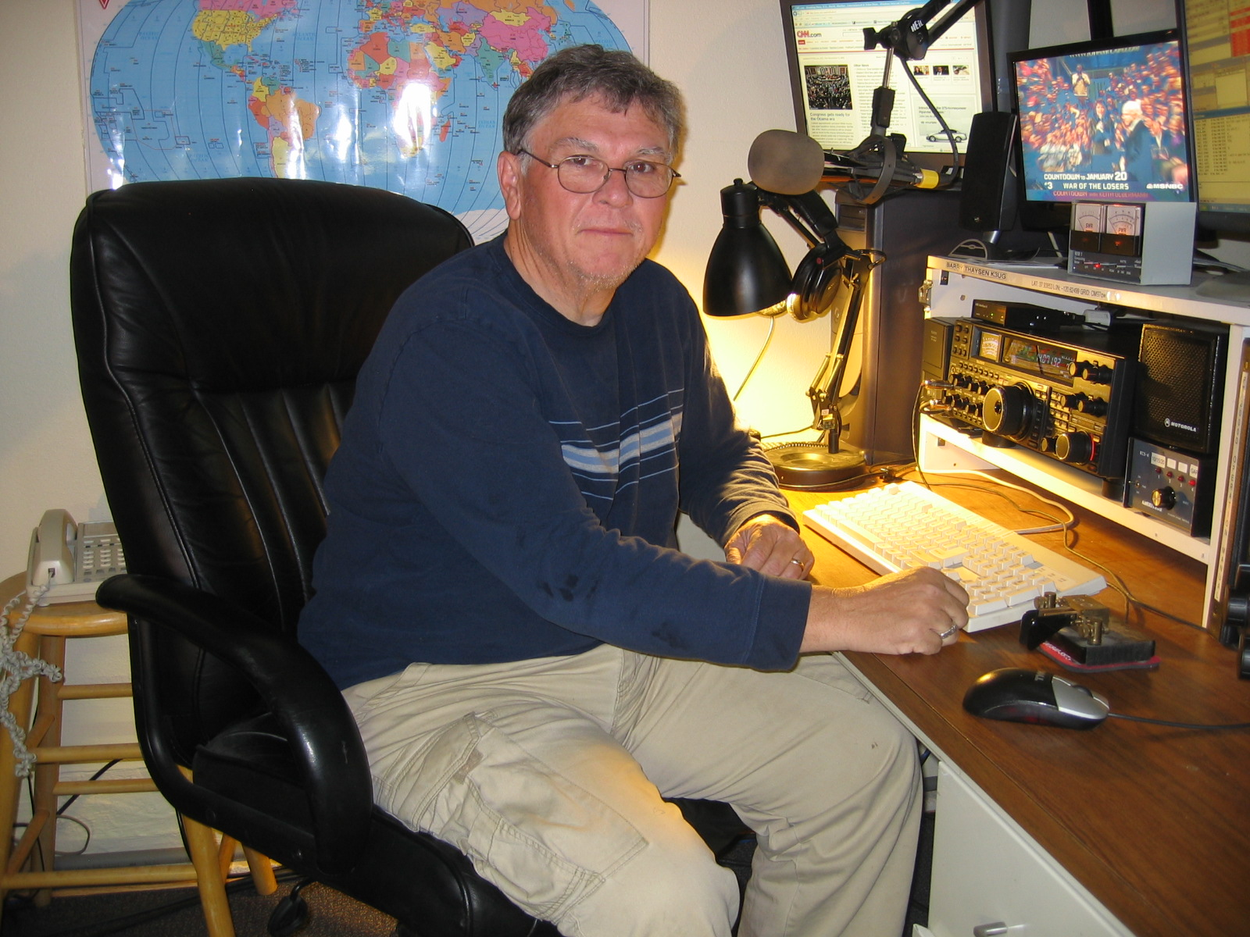

Hi Gang!
Above is a shot of my station, with my newest addition, a FT-2000D. I also use a ACOM 1010 PA, for some added horsepower, to a Force 12 C3 at 35’, as well and a Gap Voyager for 40/80/160.
73, Barry K3UG
-----------------------------------------
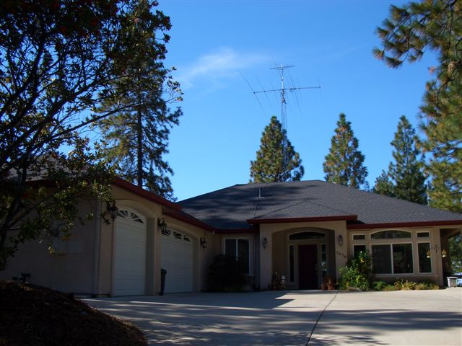

The Photo above is a shot of Mike, W6FI’s place in Placerville. Mike uses a FT-1000D, to an AL-80B in the shack. Antennas are, a F-12 C-3E at 50 ft, a N6JV/W6SR rotating 40M dipole at 55’ as well as a W6SR combo 80 dipole/160M vertical on the low bands. Mike is also active on various Vhf & Uhf bands including, 6M thru 900MHz..
-----------------------------------------
I am finally getting my station in shape, so far as antennas are concerned.
The Force-12 C19XR just smokes. Love that antenna! In the last few weeks,
I replaced the Yaesu G2800 rotor with a Yaesu G1000. Also installed a
TA-33JR about 300 feet down the hill to be used only as a receive antenna.
It works very well when noise is an issue on the main antenna.
I made a clean sweeps in CQP, and SS-CW. So I'm happy! de Bob, Hess W1RH w1rh@yahoo.com

-----------------------------------------

Hi Gang,

The P29NI trip was a success. Here are a couple of photos.

Only 3 HF operators this year due to problems with Luis, CT1AGF passport. It turns out that PNG won't let you in the country if your passport has less than 6 months before it expires. Luis had only 5 months remaining. He got as far as Singapore and had to return home. Hugh, K6HFA had to drop out suddenly at the last minute when the stock market hit the skids.

This was an IOTA trip and I was hoping for some decent pileups. I got my wish. Although IOTA has not caught on here in NA, the EUs and JAs were very enthusiastic. We put on OC-181(Garove Is.) and OC-041(Hermit Is). The three of us worked >10,000 QSOs including >1,000 on 160 which is very rare from P2.

Mike Stall, K6MYC joined us pretty much at the last moment and did a first time ever P2 on EME. I've never seen such dedication to a specialty mode! It was amazing.

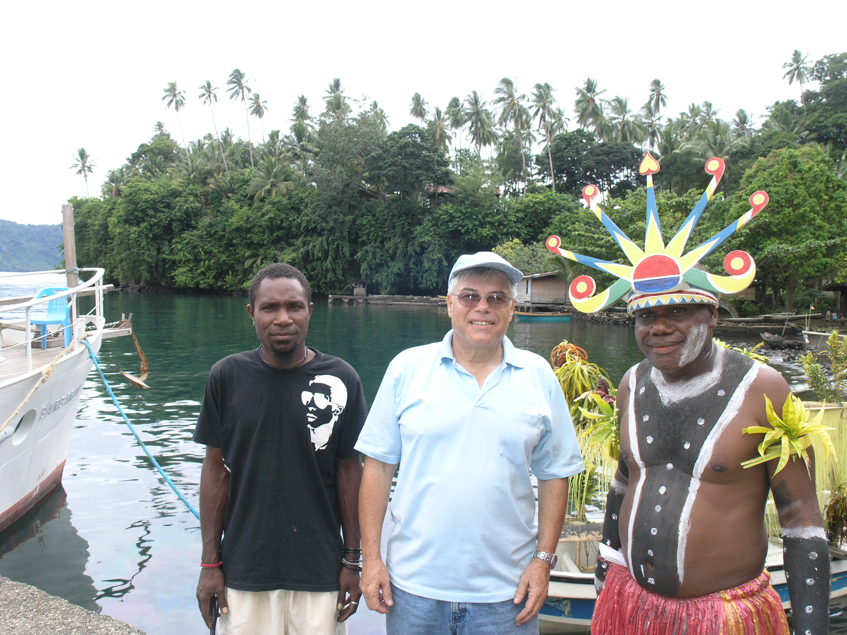

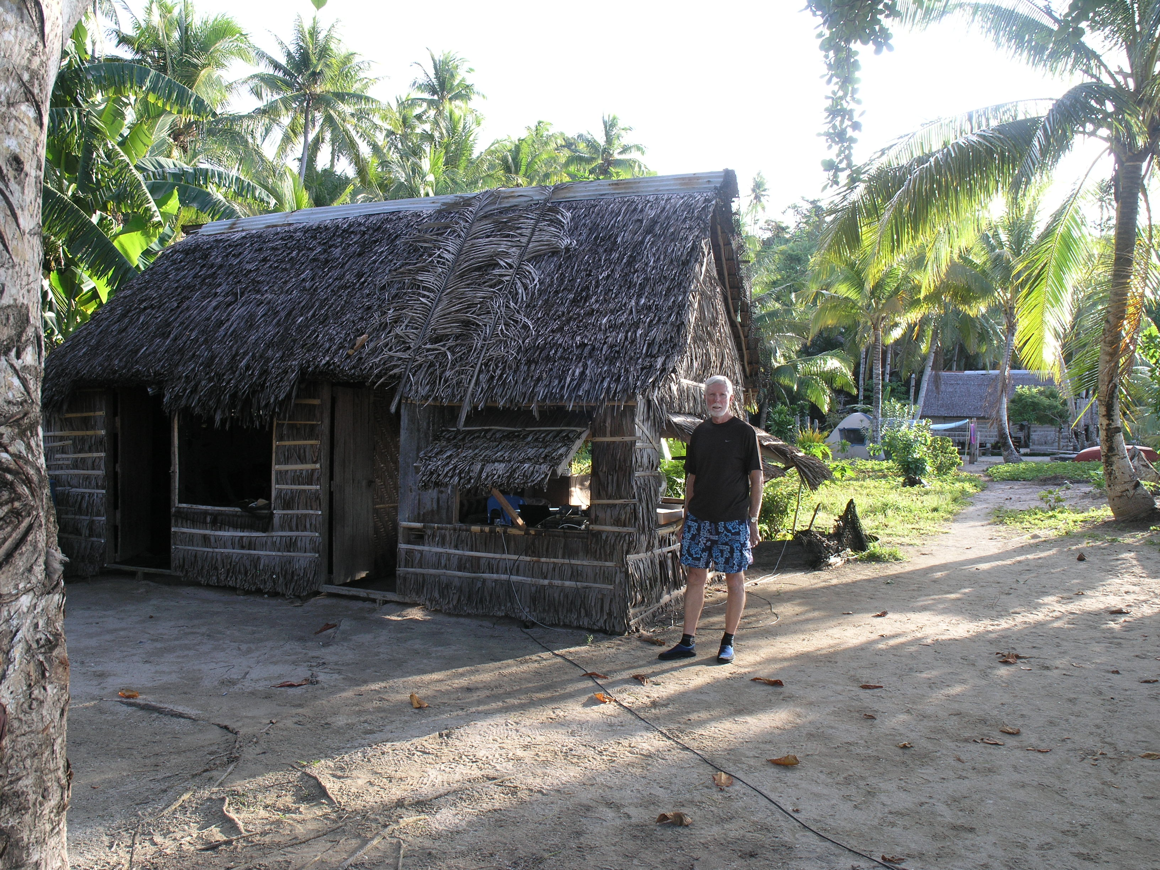

Details at http://www.425dxn.org/dxped/p29_2008/

73, Al AD6E / P29NI

EDITOR’S NOTES
160M is showing that it’s alive and well. I worked TO5DX, OG2P (twice, I know oink, oink) DF2PY, G4AMT, OZ1LXJ, and OH2BO between 03:300 and 06:00 GMT, Oct 27 thru 7 Nov, the recently repaired beverages helped a lot. I even re-matched the 160M vertical, now it’s under 1.5 to 1 over 65KHz of the band, now this 160 stuff is getting to be fun!

As part of his HMO effort, Jim, WX6V operated SS CW from here Nov 2nd. He made a clean sweep and over 500 QSO’s in less than 10 hours.

Over the past weekend (SS phone contest), Rich, NU6T made over 550 QSO’s on Saturday, and Jim, WX6V made abt. 850+ QSO’s on Sunday from our station. Karen is a good sport about having guest operators, and we both enjoy knowing that they are having a good time, and keeping the station on the air. I’m not real-keen on most domestic contests, except the 10M and 160M, so guest operators add to the NCCC or MLDXCC scores and that’s always a good thing.

In the last Nugget I mentioned that I started assembling my wife’s birthday present, an 8’X 8’ greenhouse. Man, what a job that turned out to be! With both of us working on it (mostly me), we spent over 60 man-hours assembling the damn thing. This was a COSTCO (made in China thing) but I must say that the instructions were OK, that coming from an engineer who spent most of his working life writing and/or editing technical stuff, is saying something. Anyway the project is now behind us, thank God for little favors!

I also got around to installing a Rotor E-Z into my TX2 rotor controller. I won this as prize at the 2007 DX convention. The E-Z is sold by Idiom Press, and interfaces your rotor controller to your computer, and also allows U to just adjust a direction set-point, and the rotor goes to that position, without holding down any buttons! Or, it will let you control your rotor from within a logging (such as DX4WIN) or contest program. I use N1MM and don’t have to touch the rotor controller anymore. Check out their website, http://www.idiompress.com/rotor-ez.html I love this thing, and at $160 it’s a deal.

Enough for now, CU all November 22nd………de Rick, W6SR

November 2008 Treasurer’s Report
Balance October 1, 2008 $723.85

Income: Donation 5.00
Dues 15.00
Expenses: .00

Balance October 31, 2008 $743.85
Carolyn Wilson, K6TKD, Treasurer

NOTE
Minutes from the October meeting were published in the October Nugget. Kay Anderson, K6KO, Secretary

UPCOMING EVENTS
Old Foothill Flea Market
The De Anza swap meet will start again in March, 2009.
Livermore Swap Meet

(SELECT) UP-COMING CONTESTS
November, 2008
YO International PSK31 Contest 1600Z-2200Z, Nov 21
LZ DX Contest 1200Z, Nov 22 to 1200Z, Nov 23
CQ Worldwide DX Contest, CW 0000Z, Nov 29 to 2400Z, Nov 30
December, 2008
NCCC Sprint 0230Z-0300Z, Dec 5
ARRL 160-Meter Contest 2200Z, Dec 5 to 1600Z, Dec 7
NCCC Sprint 0230Z-0300Z, Dec 12
ARRL 10-Meter Contest 0000Z, Dec 13 to 2400Z, Dec 14
SKCC Weekend Sprintathon 0000Z-2400Z, Dec 14
NCCC Sprint 0230Z-0300Z, Dec 19
International Naval Contest 1600Z, Dec 20 to 1559Z, Dec 21
Feld Hell Sprint 2100Z-2400Z, Dec 20
Run for the Bacon QRP Contest 0200Z-0400Z, Dec 22
Stew Perry Topband Challenge 1500Z, Dec 27 to 1500Z, Dec 28
January, 2009
NCCC Sprint 0230Z-0300Z, Jan 2
ARRL RTTY Roundup 1800Z, Jan 3 to 2400Z, Jan 4
NCCC Sprint 0230Z-0300Z, Jan 9
NCCC Sprint 0230Z-0300Z, Jan 10
North American QSO Party, CW 1800Z, Jan 10 to 0600Z, Jan 11
NCCC Sprint 0230Z-0300Z, Jan 16
NCCC Sprint 0230Z-0300Z, Jan 17
North American QSO Party, SSB 1800Z, Jan 17 to 0600Z, Jan 18
ARRL January VHF Sweepstakes 1900Z, Jan 17 to 0400Z, Jan 19
NCCC Sprint 0230Z-0300Z, Jan 23
CQ 160-Meter Contest, CW 2200Z, Jan 23 to 2159Z, Jan 25
NCCC Sprint 0230Z-0300Z, Jan 30
SARL Youth Day Sprint 0700Z-1100Z, Jan 31

15 November 2008 A.R.I. DX Bulletin
No 915
*** 4 2 5 D X N E W S ***
**** DX INFORMATION ****
Edited by I1JQJ & IK1ADH
Direttore Responsabile I2VGW

3B7 - Rachid, 3B8FQ says that "unforeseen difficulties" have arisen with his working trip to St. Brandon that was expected to take place later this month [425DXN 914]. The trip has officially been delayed until sometime in 2009. Further information is expected in due course. Meanwhile, Rachid is very active from Mauritius on 40-10m, with an emphasis on 30, 17 and 12 metres. CW is Rachid's currently preferred mode. QSL via K5XK. [TNX K5XK]
6W - Carsten, DL1EFD will operate mainly CW as 6V7N from Senegal
from 23 November to 5 December, including an entry in the CQ WW DX
CW Contest. QSL via home call. [TNX NG3K]
9M6 - Bob, MD0CCE, will be active as 9M6/N2BB from Sabah (OC-088)
from 25 November through 1 December, including the CQ WW DX CW contest.
He will take a 160m antenna with him, and if local noise conditions allow, he will concentrate on Top Band on
25-28 November. QSL via MD0CCE. [TNX MD0CCE]
C6 - Tom/N6BT (C6ARR), Fred/KE7X (C6AKX) and Kenny/K2KW (C6ATA) will
beactive on 160-20 metres from the Bahamas from 23 November to 1 December, including single band entries in the CQ WW DX CW Contest (C6ARR on 160m, C6AKX on 20 metres and C6ATA on 80 metres).
QSL for all of them via WA4WTG. [TNX NG3K]
CO - Ed, CO7PH and possibily other operators will be active from
IOTA group NA-086 on 16-21 December. Plans are to operate mainly
CW with some SSB on 160-10 metres, hopefully under a T47 or CO0 callsign. [TNX CO7PH]
E5 - Aki, JA1KAJ will be active as E51QQQ from Manihiki Atoll (OC-014),
North Cook Islands from 18 November to 9 December. He plans to operate SSB and CW on 80-10 metres. QSL via home call, direct bureau. [TNX The Daily DX]
> FK - Jean-Pierre, F5AHO will be active as FK/F5AHO from three New
Caledonia's islands as follows: from the main island (OC-032)on 23 November-5 December, from Lifou (OC-033) on 7-8 December and from Ile des Pins (OC-032) on 10-12 December. He plans to
operate SSB on 40, 20 and 17 metres. QSL via home call, direct or bureau. [TNX F8REF]
FT5W - Florentin, F4DYW expects to arrive at Crozet [42DXN 913] around 8 December, and to start amateur radio activities sometime between 10 and 15 December. He will operate as FT5WO in his spare time, using 100 watts and dipoles on 40-10 metres SSB. QSL via F4DYW (be prepared to be patient, as he will be back home in early 2010). [QSL via F6AJA]
GM - Russell, G5XW will be active as GM5XW from the Orkney
Islands (EU-009) between 19 and 23 November. QSL direct only to G5XW. [TNX www.rsgbiota.org]
GM - Col, MM0NDX will be active as MM0NDX/p from the St. Kilda
Islands (EU-059) on 24-27 July. He plans to operate holiday style on 80-10 metres SSB, and to take part in the IOTA Contest. QSL direct to home call. [TNX MM0NDX]
H4 - Mike, KM9D and June,KF4TUG left Honiara and are going to Pohnpei (OC-010), Micronesia (V6). According to their latest position
> report (http://www.findu.com/cgi-bin/track.cgi?call=KM9D) now theyare lying to anchor adjacent to Luaniua village, Ontong Java(OC-192), from where they may show up as H44MY. [TNX DXNL]I - Tony, IK1QBT and Emilio, IZ1GAR will be active from Lampedusa Island (AF-019) from 25 November to 1 December. They will participate from African Italy in the CQ WW DX CW Contest, Tony as IG9X (SOSB 80m) and Emilio as IG9W (SOSB 40m). Outside the contest they will operate as IG9/IK1QBT and IG9/IZIGAR, with a focus on the low bands. QSL via home calls. [TNX IK1QBT]
OD - Salvo, IV3YIM is currently active as OD5/IV3YIM from Lebanon until April 2009. He operates SSB and RTTY on 10, 15, 20, 40 and 80 metres, with some possible activity on CW, PSK and the other bands. QSL via home call, direct or bureau. [TNX IV3YIM]
OD - Ken, W5YFN has received approval from the local authorities
tooperate as OD5/W5YFN while in Lebanon, for one year starting on 16 November. [TNX QRZ-DX]
PJ4 - John/K4BAI, Jeff/KU8E, Don/W4OC and Peter/NO2R will participate
in the CQ WW DX CW Contest as PJ4A from Bonaire (SA-006), Netherlands Antilles. Outside the contest, look for the operators to be QRV as PJ4/homecalls. QSL all five calls via K4BAI. All but KU8E will be QRV from 26 November to 3 December (KU8E will QRT on 2 December). [TNX NG3K]
PY - ZY7EAM will be active on 4-7 December to celebrate the Sailor Day.Plans are to operate CW and SSB on 160-10 metres. QSL via PY7GK,bureau preferred. [TNX PY7GK]
PY - Lucio/PP5AVM, Carlos/PP5AX, Joaquim/PP5JY, Lira/PP5LL, Mario/PP5MQ and Mauricio/PP5WB will be active as ZV5V and ZV5Z from Ilha da Paz (SA-027) on 6-13 December. Look for activity on 80-10 metres SSB and CW. QSL via PP5CIT. [TNX PY2NQ and PP5MQ]
T8 - Tibi, HA7TM (T88CJ) and Pista, HA5AO (T88CI) will be active from
> Koror Island (OC-009), Palau from 21 November to 3 December. They plan to operate mainly CW on 160-6 metres, with a focus on Europe. QSL via home calls, direct or bureau. Their web page can be found at www.ha7tm.hu/t88/ [TNX HA0HW]
> UR - Special event station EO15IVK will be active on 21-30 November from the city of Volnovakha (Donetsk region, Ukraine) to celebrate the 15th anniversary of the local Kontur Radio Club. Look
for activity on the HF bands CW, SSB and RTTY. QSL via operator's instructions. [TNX UT8IM]
V3 - Terry, W6WTG (V31UR) and Sharon, N2OWL (V31WL) will be active from Caye Caulker (NA-073), Belize on 22-29 July 2009. Expect activity on the HF bands and 6 metres, and look for V31UR to participate in the IOTA Contest (25-26 July). QSL via W6UR. The logs will be uploaded to LoTW a couple of weeks after the operation is over. Further information and updates at http://www.w6wtg.com [TNX W6WTG]
VP9 - Seppo, OH1VR will be active from Bermuda (NA-005) from 25 November to 2 December. He will operate as OH1VR/VP9 (QSL via home call),and will participate in the CQ WW DX CW Contest as VP9I (QSL via N1HRA) on 20 metres. [TNX NG3K]
VU - A number of special callsigns (for instance, AU2JCB operated by VU2DSI) will be aired from 15 November to 8 December to celebrate the 150th anniversary of the birth of Indian physicist Jagadish Chandra Bose. QSL via operator's instructions. [TNX VU2DSI]
XU - Tom Callas, KC0W (ZD7X) was not able to go to Tristan da Cunha [425DXN 902] and is now in Cambodia. His requested callsign is XU7XXX and he will participate in various contests, starting with the CQ WW DX CW at the end of the month and the ARRL 160-Meter (5-6 December). QSL direct to his home call (Thomas M. Callas, P.O. Box 1058, Minnetonka, MN 55345, USA). QSLling may take quite a while, because Tom expects to remain in Cambodia for 3-4 months,and then to visit Laos and Vietnam for "an extended DXpedition" of up to three months in each country. [TNX NG3K]
YW - The YW1TI epedition to Toas Island (SA-066) [425DXN 907] is now scheduled to take place during the last week of November. Bookmark http://yw1ti.4m5dx.info/ for updates. QSL via IT9DAA. [TNX IT9DAA]
ZD8 - Between 31 December and 9 January, six members of the Cambridge University Wireless Society will operate SSB and CW as ZD8UW from Ascension Island (AF-003) on the HF bands. Expedition members will be Hugo/M0HSW, Tom/M0TJH, Simon/G4EAG, Michael/G7VJR, Gordon/G3USR and Martin/G3ZAY. QSL via G7VJR. Logs will be uploaded to LoTW shortly after the expedition. [TNX G7VJR]
TRIP TO AFRICA ---> Peter, HA3AUI is going back to Africa. He will be active in his spare time as either 6W2SC (from Senegal) and J5UAP (from Guinea-Bissau) from 15 November until about 31 March 2009. QSL via HA3AUI,direct or bureau. Peter plans to operate digital modes with some SSB and CW upon request. Bands in use will be 160-10m, with 500 watts from 6W and 100 watts from J5. [TNX NG3K]
>
> ===========================
> *** 4 2 5 D X N E W S ***
> **** GOOD TO KNOW ... ****
> ===========================
> Edited by I1JQJ & IK1ADH
> Direttore Responsabile I2VGW
>
A5100A ---> A few pictures from the current A5100A expedition to Bhutan can be found at http://lesnouvellesdx.fr/photos.php; daily updates from the team can be found on the Clipperton DX Club's website (http://www.cdxc.org/).
DX SUMMIT ALERT ---> The new DX Summit website (http://www.dxsummit.fi/)has been up and running since 23 May 2008. The old DX Summit homepage (http://oh2aq.kolumbus.com/) redirects users to the new website, but all the old DX Summit data pages are still online. Now the time has come to shut down the old DX Summit machine: it will be done on 19 November at 10 UTC, and it may cause your software to stop working. To try and maintain compatibility with older software which may no longer be supported, the new DX Summit includes a series of DX spot webpages which are 100% HTML compatible with the same pages on the old DX Summit. Simply changing the URLs in your software according to the information below should keep it working with the new DX Summit. If your software does not allow you to edit the URLs, please contact the author of your software and ask them to change the URLs according to the information below.
Latest 25 DX spots page
Old URL: http://oh2aq.kolumbus.com/dxs/dx25.html
New URL: http://www.dxsummit.fi/text/dx25.html
* Latest 1000 DX spots page
Old URL: http://oh2aq.kolumbus.com/dxs/dx1000.html
New URL: http://www.dxsummit.fi/text/dx1000.html
> * Latest 10000 DX spots page
Old URL: http://oh2aq.kolumbus.com/dxs/dx10000.html
New URL: http://www.dxsummit.fi/text/dx10000.html
Software authors who wish to implement data exchange with the new DX Summit should visit http://www.dxsummit.fi/technical.aspx for information on data formats and URLs. If your software does not work with the new DX Summit, we encourage you to forward this information to the author of the software you are using. [TNX OH2BH]
DXCC NEWS ---> Bill Moore, NC1L reports that the following operations are approved for DXCC credit:A52AM Bhutan 20 March-26 September 2007 operation (*)CY0X Sable Island 2008 operation VU4MY Andaman & Nicobar Isls 24 October-3 November 2008 operation VU7NRO Lakshadweep Isls 24 October-3 November 2008 operation VU7SJ Lakshadweep Isls 2008 operation(*) If you had an A52AM QSO rejected for credit within this date period send an e-mail to dxcc@arrl.org to be placed on the list to receive an update.
P29NI ---> The log search for P29NI (OC-181 and OC-041) is now up
and running at http://www.425dxn.org/dxped/p29_2008/
QSL VIA LA9SN ---> Please note that while JX9SN (October 2008) should go direct only (Harald Kjode, Postboks 404 Sentrum, 6401 Molde, Norway), the QSL cards for Al's other activities (e.g. OY/LA9SN and TF/LA9SN) can go either direct or via the bureau. A log search can be found at http://www.la9sn.com/log/ [TNX LA9SN]
- SPRATLY 2009 ---> According to the latest update at www.spratly2009.com, the 1-14 March 2009 expedition to the Spratly Islands [425DXN 889] has been postponed until further notice "due to a combination of personal and logistical reasons". For the time being, "donations will be returned
> to those sponsors who kindly made contributions to the proposed DXpedition".
- + SILENT KEYS +
Zoran Krnjeta (9A2CY) passed away on 9 November at 56 years of age, following a brain hemorrhage. An active DXer and a member of
> the 9A1BOP radio club for almost forty years, his main interest was in RTTY and PSK31.
Other recently reported Silent Keys include Tom Baker (K8MMM), Bob McCourt (KI4RU), Edward Joseph Gassman (N8HTT), Bogdan I. Voichuk (UR0YY), Paul D. Casdorph (W8HXX), Leo D. Hodge (ZL2AJB) and Kuo On "Tom" Wong (VE7BC), whose seven-year effort was instrumental in getting PRC on the air- BY1PK, the first Amateur Radio Club in China, was activated on 29 March 1982.
QSLs received direct or through managers: 3DA0VB, 4K1L, 4K6GF, 4L1MA, 4W6R,4X/AA4V, 4Z8BB, 5H3VMB, 5J0M, 5W0JT, 5Z4/RW1AU, 5Z4/UA4WHZ, 5Z4RS,6E4LM,6L0NJ/4(AS-093), 7Q7VB, 7X/DB1JAW, 8R1EA, 9K2/SP4R, 9M6OO, 9M8Z, 9U0VB,9W2LLK, 9X0R, 9X0VB, A25/DL7DF, A25VB, A45WG, C4M, C6APR,CE9/CE3VPM,CO6WD,CO8LY,CU2/OH2TA, CU2A, CU7/DL5AXX, CX1AA, CY0X, D20VB, D2NX, D4C, D60VB,DT8A, E20WXA, E51NOU, E71AA, EK6TA, EL2DX, ES2Q (EU-149), EX2F, EY8MM,F4FEP/P (EU-094), FK8HC, FO/N6JA, FO/OH1RX, FP/KV1J, FP/W9ILY, FR5MV, FR5ZL,G4DBX, GS8R (EU-009), H40MY (OC-163), HB0/HB9QQ, HC5WW, HC8N, HI8A,HR9/WQ7R, J75KG, JA6WFM/HC5, JD1ACH, JD1BMM, JY4CI, K7A, KG4SS, KH7B,KL7DX(NA-234), KP2M, KP4/NY6X, MU0BKA, OH0GG, OH0X, OJ0B, OJ0J, PY0FF, PZ5Z,R1ANR, R1FJT, RI0F (AS-149), RW2F, RW2FWA, ST2VB, T209DX, T94CT,TA3D,TF/DJ2VO(EU-071), TF3GC, TK7C, TM7F, TN6X, TO8S (NA-114), TY6A,UE9WFF/1,UN9L, UT5UGR, V51VV, V63DX, V85SS, VE8RCS/VY0, VI9NI, VK9XHZ,VK9XMM,VK9XOR, VK9XWW, VP8QI, XE2WWW, XR7A (SA-043), XR7W (SA-053), XU7DLH,XW1B,YB0WR, YI9WV, YS3/I2JIN, YU150AU,YU8/OH2R,ZA1Z,ZD8LP,ZF1DX,ZL7/KH0PR,ZP6/DL7UFN, ZP6/DL7VEE, ZP6CW.

SB PROP ARL ARLP047 ARLP047 Propagation de K7RA
We soon may be talking about a day or two without sunspots as the norm, perhaps when looking at a preceding month -- quite the opposite of noting the few days with sunspots. It seems like a long time ago because of the long strings of spotless days. We saw eight days in a row with visible sunspots around mid-October, followed by another eight days around the start of November, then after just three days of no spots. By the end of today -- Friday, November 14 -- we may see five straight days, possibly followed by more. We have to look at last year to find long periods without spotless days. From June 25, 2007 until July 19, 2007, there were 25 days with sunspots that were continuously visible. From April 25, 2007 until May 23, 2007, there were 29 days with spots; from December 30, 2006 until February 10, 2007, there were 43 days with spots. This makes January 2007 the last time we observed a calendar month with no spotless days. Why are sunspots important? They correlate with a reflective or refracting ionosphere. Here is a nice picture from University of Iowa illustrating the earth with ionosphere: http://www.iihr.uiowa.edu/projects/schumann/images/IonosphereLayers.gif Another one, from G4NSJ, shows a very basic diagram of a shortwave radio signal traveling a great distance via the ionosphere: http://www.g4nsj.co.uk/images/wave.jpg There are variations influenced by time of day, season and location, but generally the higher the sunspot number, the higher the frequency that can be used for communication. This is important, because when you double the frequency you are operating on (for instance, from 20 to 10 meters), the relative size of your antenna can be cut in half to still have the same efficiency. So, with enough solar activity, you could communicate around the world on 10 meters with a highly efficient directional antenna that is much smaller and easier to construct than an equally efficient 20 meter antenna. At the higher frequencies, there is also less absorption of higher frequency shortwave signals. There is a critical number called MUF (Maximum Usable Frequency) that can be calculated based on the factors mentioned above: time of day, time of the year, the two locations trying to communicate and the level of solar activity. For radio waves at a frequency above the MUF, they can just pass on through the ionosphere, never to be heard again. For calculating conditions based on these factors, check the reference to the same W6ELprop program mentioned in last week's Propagation Forecast Bulletin ARLP046 at, http://mysite.verizon.net/k9la/id9.html. Check out the other references on the same K9LA web page, which are excellent. The ARRL SSB Sweepstakes Contest is this weekend. With the recent sunspot activity, conditions should be better on 15 meters than they would be without sunspots. For example: California to Ohio. If there had been no sunspots leading up to the contest weekend, 15 meters looks rough, but could open from 1800-1930z, perhaps as early as 1600 to as late as 2100z. But with recent sunspots, a great opening from 1630-2100z is likely and could start an hour earlier and end 30 minutes to an hour later. Over that path and over this weekend, with no sunspots the MUF would rise above 20 MHz at 1730-2000z, peaking around 20.6 MHz at 1830z. But with sunspots over a few days, the MUF is likely to go above 21 MHz from 1630-2100z, peaking at 23.7 MHz around 1830z. On 20 meters with no sunspots, the path looks good 1430-1530z and 1800-1830z. With sunspots 20 meters looks good 1430-1500z, and excellent 1600-2000z. 40 meters is good over the path day and night, sunspots or none. Strongest signals are from when the Sun sets around 0047z in California to within the hour after the Sun rises in Ohio around 1219z. Jeff Hartley, N8II of Shepherdstown, West Virginia wrote to us last week about the CQ Worldwide DX Phone Contest, October 25-26. Jeff wrote, "I operated the CQWW single band on 15M and the band was poor compared to most years, probably about the same as in 2007. The skip zone was long enough that I didn't work several active northern Caribbean countries until mid-afternoon Sunday. There appeared to be sporadic E to VE1/VY2 and VE3 Saturday morning and to VP5/VP9/C6 on Sunday. The closest F2 contact to my south was KP2M. There was decent propagation to very southern EU both days. I caught VU7SJ (loud) about the same time as the Es around 1400Z Saturday and VU2PAI (weak) called in Sunday around 1600Z for my best polar opening DX." He continues, "It was possible to work about 30 zones on 15M from the USA. From 1245-1355Z Sunday there was a big opening with S9+ EU signals about as far as Lithuania. 3 Russians UA3 and UA6 were worked and one UR. 5R8FU was loud Sunday afternoon with a huge pile-up; all of Africa was workable, but zones 34 (missed), 36, 37 and 39 were pretty rare. Best Pacific DX was AH0 around 23Z Sunday." He goes on to say, "40M and 30M seem to be staying open to EU quite late (after my sunset 30M, thru 0200Z 40M) some days which is encouraging." Owen Duffy, VK1OD of Ainslie, near Canberra in Southeast Australia, sent in a link to a chart he made of spotless days around the solar cycle transition. See it at, http://www.vk1od.net/solar/spotless.htm. Also check out the rest of his site at, http://www.vk1od.net/. If you would like to make a comment or have a tip for our readers, email the author at, k7ra@arrl.net. For more information concerning radio propagation, see the ARRL Technical Information Service web page at, http://www.arrl.org/tis/info/propagation.html. For a detailed explanation of the numbers used in this bulletin, see http://www.arrl.org/tis/info/k9la-prop.html. An archive of past propagation bulletins is at http://www.arrl.org/w1aw/prop/. Monthly propagation charts between four USA regions and twelve overseas locations are at http://www.arrl.org/qst/propcharts/. Instructions for starting or ending email distribution of this bulletin are at http://www.arrl.org/w1aw.html#email. Sunspot numbers for November 6 through 12 were 11, 0, 0, 0, 16, 18, and 21 with a mean of 9.4. 10.7 cm flux was 68.6, 67.8, 68.3, 68.4, 69.3, 71.4, and 70.9 with a mean of 69.2. Estimated planetary A indices were 1, 8, 14, 12, 3, 1 and 2 with a mean of 5.9. Estimated mid-latitude A indices were 0, 7, 11, 10, 3, 1 and 4 with a mean of 5.1.

MLDXCC 2008 Meetings 3rd Saturday (pending contest or other conflicts). Tentative Schedule below:
November | 22
December | 20??

Membership Criteria
Membership criteria may be obtained by writing the Secretary/Treasurer at:
MLDXCC
PO Box 1073
Pine Grove, CA 95665-1073
The club’s website is: http://mldxcc.org

The MLDXCC NEWSLETTER
Information may be reproduced provided credit is given MLDXCC.

2008 Officers of the MLDXCC
President, Richard Hill, NU6T
REHill@ix.net.com

Vice President, Shirley Rose, AA6K roses@prodigy.net

Director, Dick Wilson, K6LRN
k6lrn@arrl.net

Director, Norm Wilson, N6JV
n6jv@n6jv.com

Director, George Campbell, KG6OJV
Kg60jv@yahoo.com

Treasurer, Carolyn Wilson, K6TKD
k6tkd@arrl.net

Secretary, Kay Anderson, K6KO
k6ko@arrl.net

Nugget Editor, Rick Samoian,W6SR samoian@directcon.net

QSL Manager, Norm Regan, WA6SJQ
Qsl73@linkunet.net

Publicity Chairperson, Brandt Woodard, K6BEW. k6bew@yahoo.com

ARRL Awards Checkers
DXCC, Gary Stillwell, KI6T & Ken Anderson, K6TA

ARRL Sixth District QSL Bureau
P.O. Box 970 Fairfax, CA., 94978-0970
Comments or questions on this bureau's operation may be directed to kc6awx@arrl.net See the W6 Bureau home page (http://www.kqlz.com/qslbureau6/)

