Volume 15, Number 06 June 2010

The Nugget

The Newsletter of the Mother Lode DX/Contest Club.

MEETING DATE, LOCATION & PROGRAM
When: Our next meeting is Saturday, June 12th at 12:00 noon.
Where: Mountain Mike's Pizza in Martel, CA. They are located in the shopping center with Save-Mart on Highway 88, just west of Highway 49. Our meeting room is reserved from 11AM-3PM. At our regular time (noon) (The room is reserved from 11AM-3PM.) See the club’s website at http://www.mldxcc.org/ and click on “meetings” for a map and more information.
What: The program will be a (yet to be selected) video presentation.

Below is a photo of some of us at the May 2010 meeting in Martel.
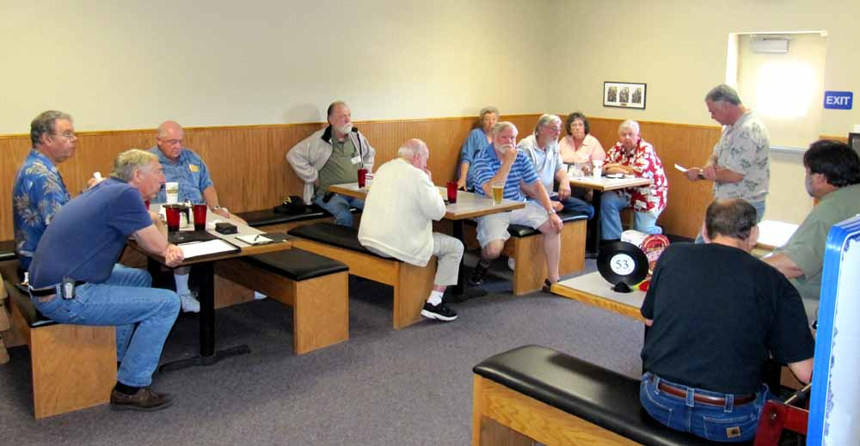

From the Prez:
Wow, half the year has passed by so far. With the weather getting better now, it’s time to begin those needed antenna repairs.
Don’t forget that Field Day is at the end of this month, I hope you find some time to participate in it.
In the WPX CW contest we from WC6H using N6RC, KF6T, WX6V, WJ6O and myself operated in the M/2 category. In spite of marginal band conditions, we all had a fun weekend, and manage to make 3194 contacts with 724 prefixes for a score on 5,048,452. I want to thank all the MLDXCC members for giving us a contact and for sending your logs in with credit going to the NCCC.
Our biggest club competition the CQP will be upon us before you know it, this year let’s see if we can double last years score. We don’t seem to have a lot of outside competition so let’s just compete against ourselves, shall we? In order to double our score we will have to get some more of our members on the air and recruit some new hams to join us. We need to optimize our stations, as well as increase our personal skill level. We have 3 months to get ready and I know this club can do it. To double our score in 1 year will be an accomplishment we can all be very proud of.
Next month is the joint meeting with the NCCC in Stockton, I want to thank Shirley, AA6K for all his hard work in putting this meeting together. Be thinking about CQP and what you can do to help the club double it’s score. 73, Rich WC6H

VP’s QRM
VP’s QRM

Our next Meeting will be on Sat 12 June at Mountain Mike’s Pizza in Martell, CA. The program will be a video which has not yet been selected.

Cycle 24 continues to try get going. It is very slowly improving and perhaps it will have some pleasant surprises. I recently read a forecast that predicted that the peak will be lower that the cycle 23 peak but it could last as long as the recent 2½ year minimum we are emerging from. That could be great news.

DXCC news indicates that Malyj Vysotskij Island, the present R1MV DXCC entity will be deleted in the near future as a result of an agreement between Finland and Russia. That will bring the Honor Roll one step closer for a number of us.

On the topic of chasing DX I did manage to work the E4X Palestine expedition Friday evening on 20M CW with my 100 watts. They are quite strong (peaking S5 to S7) on CW but only a whisper on SSB.

Our joint meeting with the NCCC will be held at The Old Spaghetti Factory in Stockton (located at March Lane & I-5) in their large banquet room on Saturday 24 July between 12:00 (noon) and 3:30 pm. This is the same venue as 2009 joint meeting. It proved to be a great central location with excellent food and service at a reasonable price. Our presentation: Paul Ewing, N6PSE, will give a presentation on the YI9PSE Kurdistan (Northern Iraq) DXpedition of 2010.

A reminder that we continue to need topics and presenters for our club meetings so if you have something please let us know. 73, Shirley, AA6K

W6OZI, W6RXK and K6GLH Present the First Ever Gold Country Ham Swap and Roast

Saturday, July 17, Swap Starts 7:00am
Followed by FREE lunch at Noon - Raffle Prizes!

At the Heavy Metal Radio Ranch of Bob DeMarco, W6OZI, near Burson CA
www.volcano.net/~k6glh/

Joining us will be our local Radio Clubs: Calaveras (N6FRG), Amador (K6ARC), and the Motherlode DX club for a Swap Extravaganza! Get to meet the hams in the area! Check with the clubs to see what other activites they are planning.

Seller spaces are FREE, just bring your own table.
Directions: Burson is between Valley Springs and Lake Camanche on Hiway 12. Take Hiway 12 to Toreno Way, North to the Cul de Sac. Look for the beam on the Skyneedle and head up the driveway. GPS users: Enter 4395 Toreno Way,
Burson CA on your GPS Unit for easy nav.

Talk-in on 145.20 Simplex. For additional information email: k6glh@volcano.net

Looking forward to seeing you guys there!

Robert DeMarco / tqi-bob@sbcglobal.net
TOP QUALITY INSULATION & FIREPLACES INC.
P.O. Box 775 / 105 Main St.
Valley Springs, CA 95252
www.tqinsulation.com
Tel. 209.772.2501 / 800.464.1675
Fax 209.772.3590
==========================================

Rich, NU6T sent me the following, thanks, Ed.

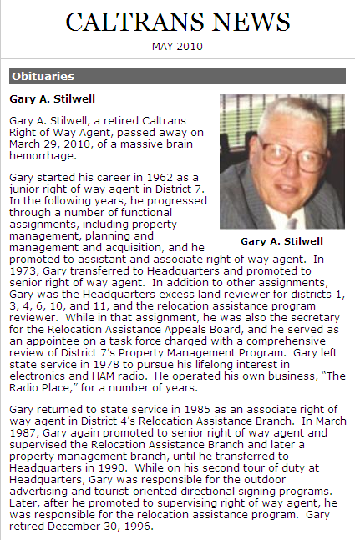

Tube of the Month de Norm, N6JV

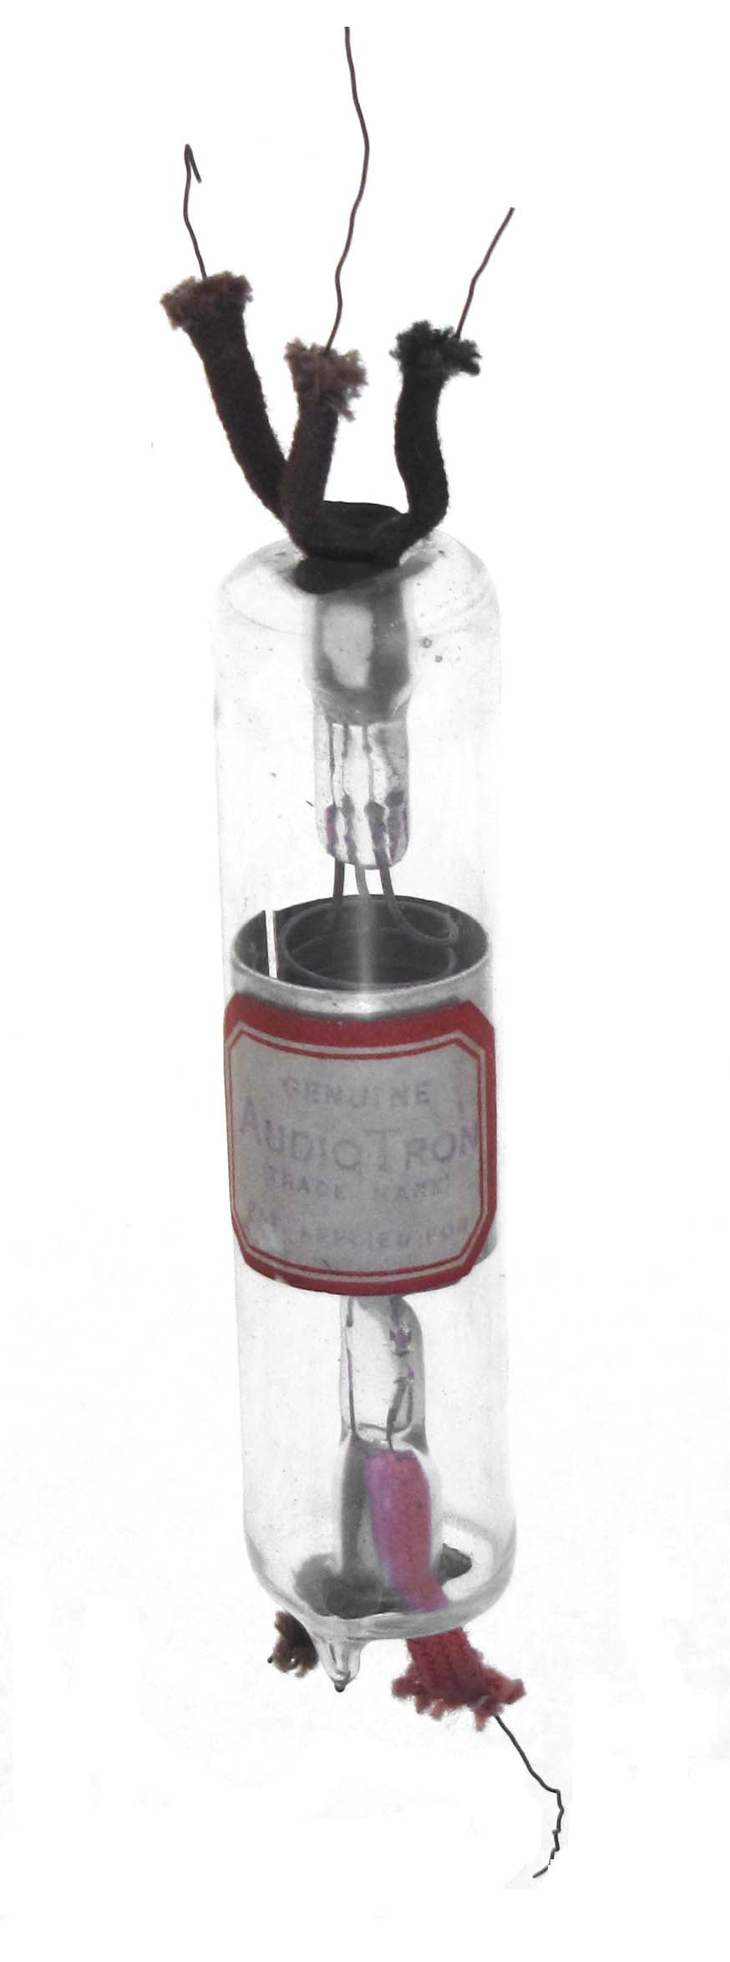

AUDIOTRON

A California Pirate

With de Forest’s success with his new triode, there were a few who tried to capitalize on the new technology. Elmer T. Cunningham of Oakland, California was one of the first. The early hams were always looking for a deal and Cunningham wanted his cut. He produced a triode that was made out of a test tube and called it the AudioTron or Audiotron and always priced it for less than de Forest. It featured an aluminum plate formed in a cylinder and a copper grid wound on a fat pencil like the one they gave you in the first grade. The grid was supported on only one end so it would vibrate wildly if someone tapped the table. As the signals were arcs and sparks, I guess it didn’t matter much with the microphonics. Very small lengths of platinum wire were required in each lead as it passed through the presses. This was to make a vacuum seal. No two Audiotrons were exactly the same. Manufacture started in 1915.

Californians have always admired their legendary bandits like Black Bart or Zorro. The legend of Cunningham has many stories that may be hard to prove. One popular tale was that when de Forrest’s lawyers were hunting them down, they would load all the gear in the Model T and move to another garage. De Forest finally caught up with them and the patent infringement suit was eventually settled out of court. De Forest made their own version of the Audiotron, but the Cunningham was always priced $.25 less.

After World War I, Cunningham continued production of the Audiotron. In 1919 a new company called the Radio Corporation of America was founded. They were a holding company and had acquired the de Forest and Fleming patents. The next lawsuit was also settled out of court. The agreement between RCA and Cunningham became a legend on its own. If you can’t whip ‘em, you join ‘em.

RCA allowed Cunningham to make 5000 more Audiotrons and then stop production. RCA also agreed to supply tubes to Cunningham at a discount for sale on the West Coast. Cunningham had become an RCA distributor and sold vast numbers of tubes. All of the tubes made for Cunningham were not marked RCA. GE was the actual manufacturer and an RCA UV200 that was to be sold to Cunningham would be marked C300. Same tube in a different box. People swore that the Cunninghams were better than the RCA and everyone raked in the cash. This arrangement lasted into the 1930s. RCA had a monopoly that they disguised by creating competition within their own organization. Who was the real pirate?

The following three photos were shot at the MLDXCC CQ WPX CW effort at WC6H’s QTH in Burson, CA.

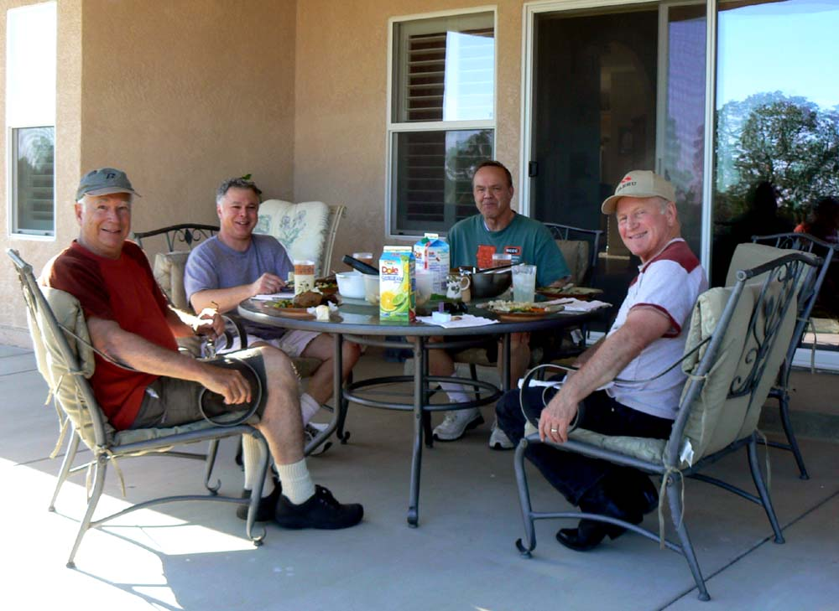

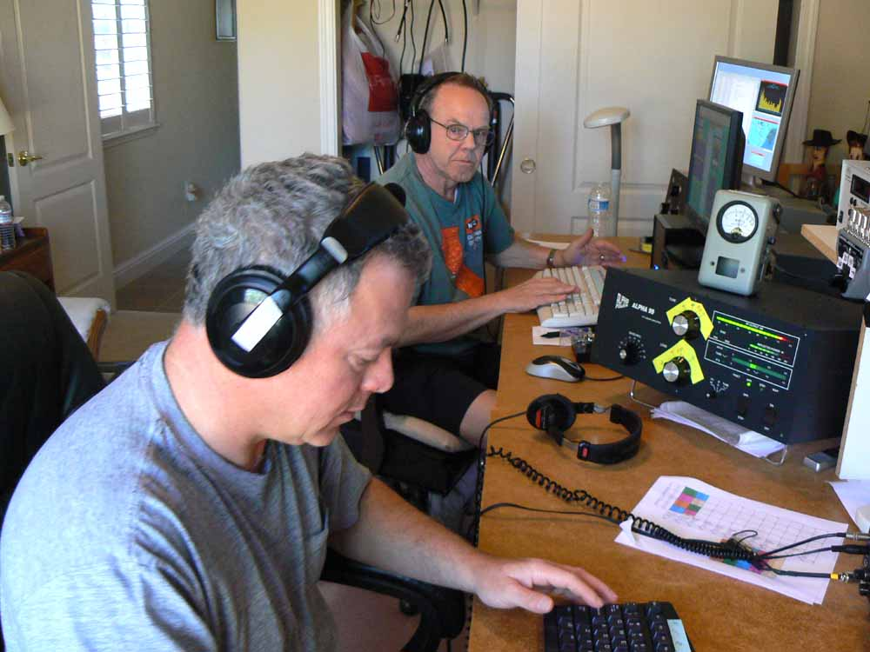
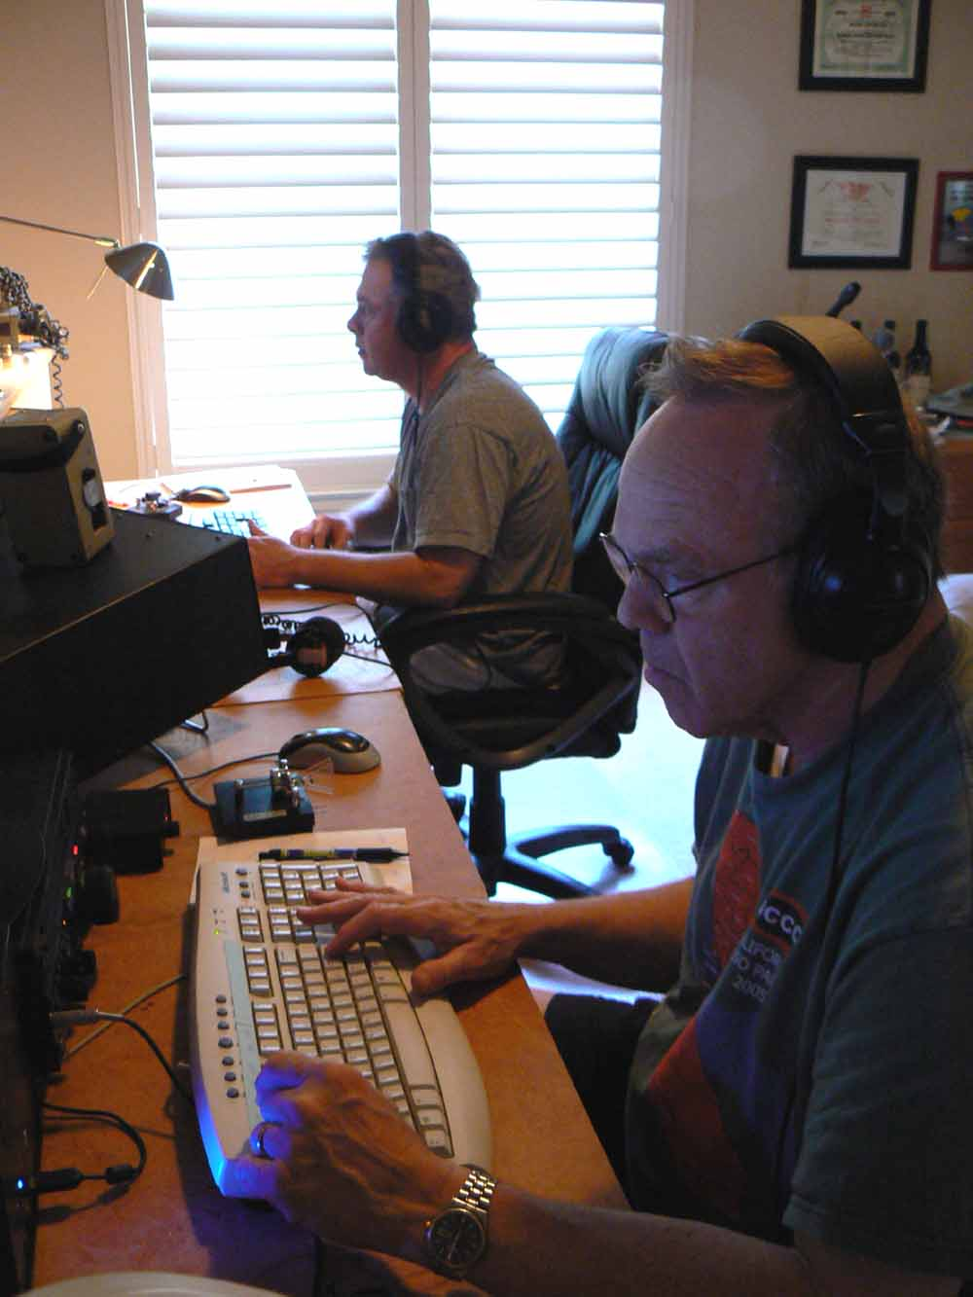

The following photos were taken during the CQ WPX CW contest effort at the K6LRG station in Livermore. 73, John K6MM
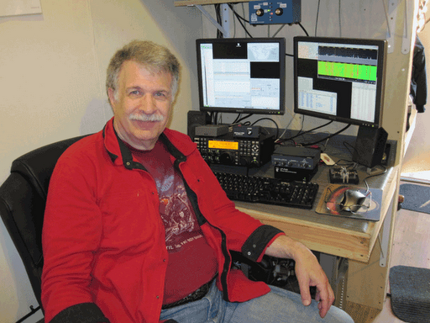
John, K6MM
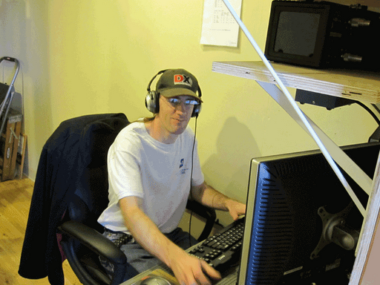
Iain, N6ML

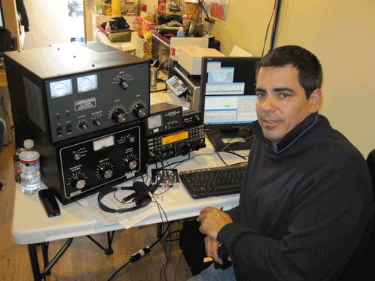
Eric, N6SPP
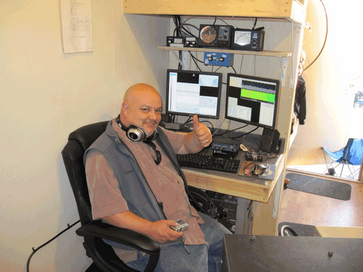
Chris, N6WM

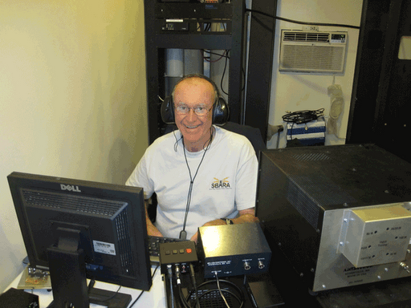
Al, WT6K

Member news/feedback/Announcements.

Henry 3K Classic Power Amp. For sale. 10 - 80 m (NO 160) see the ad at the following:
http://hamcq.com/used-equipment/henry-3k-classic-export-linear-amplifier/

ki6cg@yahoo.com

Is my best email address.

Still snow on the mountains in Glacier Park. That starts about 3000 feet above house. Montana phone # 406-892-9648 George, KI6CG

=========================================
Having worked YI9PSE –Iraq & TL0A –Central Africa Republic in the past few months, K6LRN is creeping toward DXCC CW Honor Roll. All I have to do is get the cards/confirmations…either paper or LotW.
To work the remaining eight looks to be a formidable task.
They are:
5V7 Togo (a possibility)
7O Yemen (slim)
FR/g Glorioso Is (consider FT5GA…’nuf said)
FR/j Juan de Nova (probably same as FR/g)
FR/t Tromelin Is (ditto)
P5 No. Korea (slim to impossible)
VK0 Heard Is. (last trip there in ’97)
VK0 McQuarie (ham there now-no gear-does he operate CW?)
ZS8 Prince Edward & Marion (what are chances of ZS8M operating CW? de Dick, K6LRN

N6JV was single OP High Power on 20 meters only for the WPX contest. A total of 734 QSOs for a final score of 481,656. This was the smoke test for the new 20 meter, 3-500Z amplifier. If it won't blow up in this contest, it will live forever. Norm, N6JV

Editor’s Notes de Rick, W6SR
Hi All
Karen and I will be in LA at our granddaughter’s high school graduation from Wed. the 9 until late Friday night. This Saturday we are schedule to attend a memorial service at 4PM, in El Dorado Hills, for the husband of one Karen’s best friend’s. I will try to make the meeting, but will have to leave by 2:30. I would much rather spend my time at a MLDXCC club meeting than a memorial service. But, sometimes ya’ just gotta’ do what ya’ gotta’ do.

I did work the E4X and 3C9B on 20 and 17M, respectively. The 3C was a new band country the E4 was just for drill.

I have (still) been playing around with the GS-35B HB power amp and now have the output power up to 2KW with only 3300V on the plate, when in service it will run at 4KV so the potential power out S/B 2.5+KW with the new P/S. Plenty of headroom for a 1500W output, 100% duty contest amplifier. Enough for now, see ya’ all at the meeting, I hope.…….de Rick, W6SR

June 2010 Treasurer’s Report

Balance May 1, 2010: $2268.35

Income:
Dues: K6AUC, ND6S, K6GT. 50.00

Expenses: Donations to NCDXF in
memory of Dick Zuttermeister N6TNX
and Gary Stilwell KI6T. 100.00

Balance May 31, 2010: $2218.38

Carolyn Wilson, K6TKD
Treasurer

The photo’s below are of the newly completed 900 MHz repeater for Yuma, Arizona. The radios are Motorola Maxtrac units and the controller was made by NHRC. The final amplifier is capable of 150 watts and the big duplexer was made by WACO in Texas. Completed by Norm, N6JV.

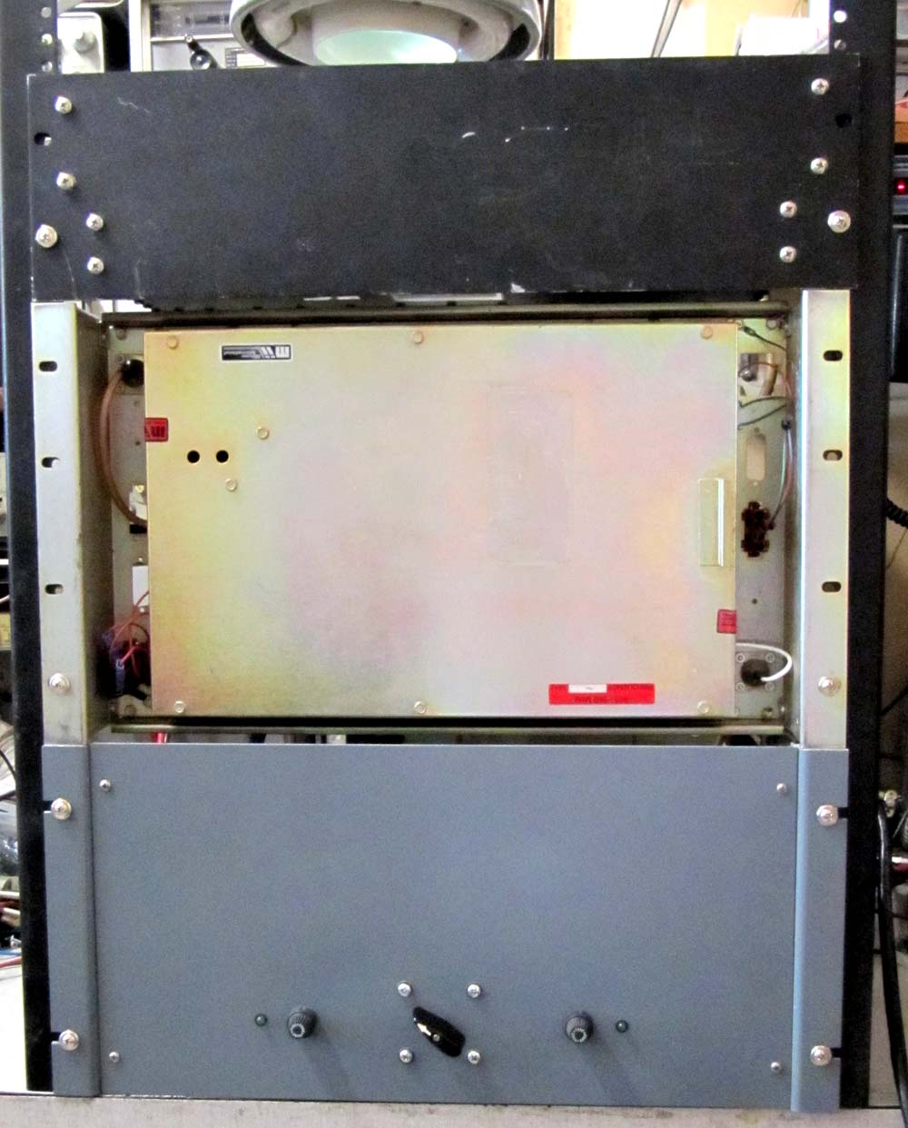

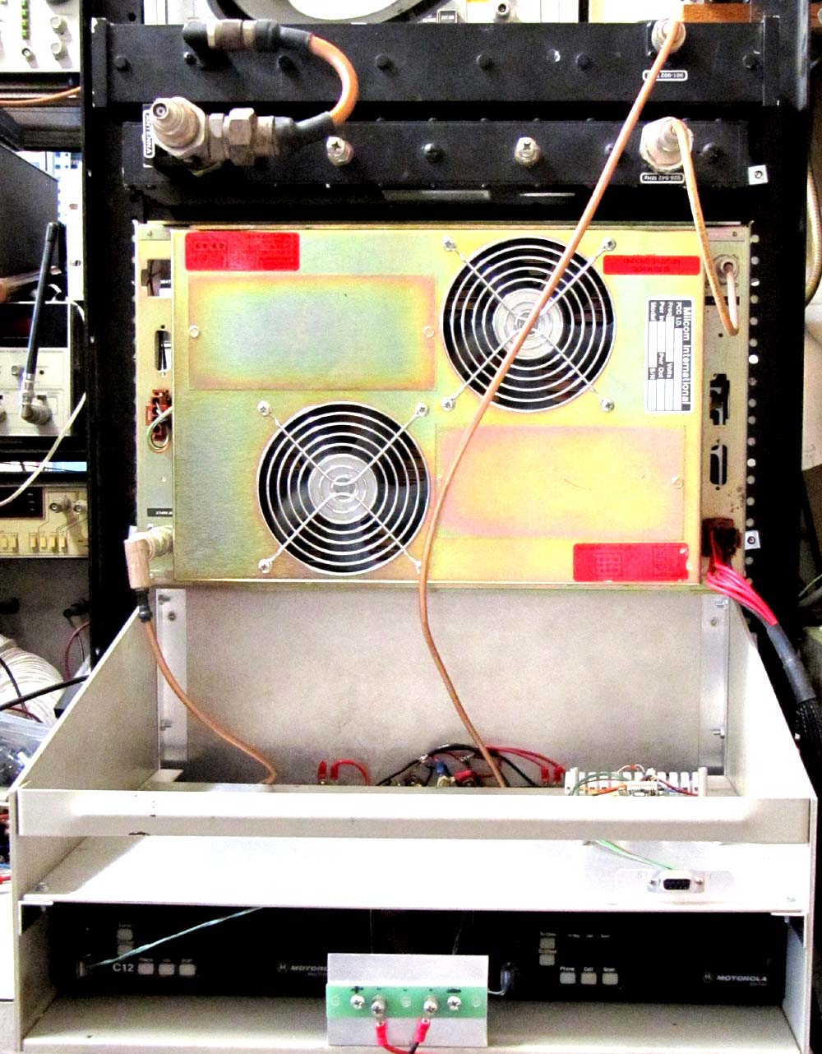

MOTHER LOAD DX / CONTEST CLUB
GENERAL MEETING, May 15TH, 2010

Call to order
President Rich Cutler, called the meeting to order at 12:00 Noon. The meeting was held at Mountain Mikes Pizza, in Martel.

Officer Roll Call
WC6H – Rich – President
AA6K – Shirley – Vice President
K6TKD – Carolyn – Treasurer
W1RH – Bob – Secretary
NU6T – Rich - Director
K6TA – Ken - Director
W6SR – Rick – Newsletter Editor
N6JV – Norm – Webmaster
KF6T – Jack – NCCC Liaison

MOMENT OF SILENCE
A moment of silence in memory of Gary, KI6T, now a SK.

OLD BUSINESS

How to Spend Our Money
Dick, K6LRN, moved to donate $50 in memory MLDXCC silent keys, to the NCDXF. The motion was seconded and the vote of approval was unanimous.

Building Membership
Rich, WC6H, is concerned about our membership dying off as members get older. He reminded the Club that we need to continue to attract new members if we are to remain a viable club.

Bob, W1RH, said that we need to motivate the local clubs, via newsletter articles, presentations, etc.

K6TA suggested our members bring DXpedition tales to local clubs.

The suggestion was made that we use the ARRL 10 Meter contest as a recruitment tool. Rich, NU6T, suggested a VHF Contest also. Bob, W1RH, said that local clubs should be notified of the 10 Meter Contest and MLDXCC should seek out new members after-the-fact. Rich, WC6H, brought up the possibility of a rookie award to be given by MLDXCC to new contesters.

Ken, K6TA, said that the Club should consider “dues-optional” membership. Norm, N6JV, followed by suggesting a waiver of first year dues for new members. Carolyn, K6TKD, mentioned that new members joining in the last quarter (10 Meter Contest) would have dues waived for the following year. There was no resolution on this discussion.

Field Day
Jack, KF6T, mentioned that the snow pack us from using the Peddler Hill area.

NEW BUSINESS

Replacement Director Position
Ken, K6TA, was appointed to the position of MLDXCC Director, filling the position left open with the passing of Gary, NI6T. The vote was unanimous in favor of Ken’s appointment.

ARRL DXCC Card Checker
Rich brought up the position of DXCC Card Checker, function left vacant with the death of Gary, KI6T. The Club must nominate a card checker, approve the nomination and submit the Club approved representative’s name to the ARRL DXCC committee. Rick, W6SR, was nominated and the subsequent vote was unanimous. The Club will send a letter to Bill Moore, NC1L, informing him that we are requesting the seat left vacant by KI6T be filled by Rick, W6SR.

Club Scores – WPX
NCCC requested that MLDXCC members list NCCC as the contest club when submitting scores in the CQ WPX contests. NCCC stands to set a new club record this year, which was not expected, hence the last minute request for scores that would normally go to MLDXCC.

Dick, K6LRN, was concerned about MLDXCC’s identity fading away as a result of more and more scores being assigned to the large contest club. For the record, he would like to see NCCC/MLDXCC members submit their scores, listing MLDXCC as the affiliated club for applicable contests. He would also like to see more NCCC participation in the joint NCCC/MLDXCC meeting.

Rich, NU6T, would like to see some recognition from NCCC for scores submitted by MLDXCC members.

Bob, W1RH, suggested that MLDXCC needs to focus on one other contest, besides CQP, and rally our members to go for an all out effort as they do for CQP but which is not the case for virtually every other contest that the Club has elected to participate in. He also suggested that MLDXCC needs a liaison who regularly attends NCCC meetings and is a MLDXCC member.

Rick, W6SR, suggested that a contest worthy of a strong MLDXCC membership effort is the ARRL 10 Meter contest. He added that this contest is a terrific equalizer for little pistols and big guns.

Regarding the NCCC liaison position, Rich suggested the Club appoint Jack, KF6T. A vote was requested and it was unanimous in favor of Jack’s appointment as Liaison.

Next Meeting
June 12th, at Mountain Mikes in Martell.

K4M Video
Bob, W1RH, announced that MLDXCC was sent a copy of the K4M, Midway, video by the Northern California DX Foundation in response to our donation. The video will go in the library which is managed by Dick and Carolyn. W1RH borrowed the video to show to the El Dorado club.

Joint Meeting
Shirley, AA6K, announced that Ken, W6PSE, is confirmed as the guest speaker.

We need a head count for a full-room reservation.

W1RH will bring the sound system and wireless microphones.

WC6H will bring a projector. W1RH will bring a backup projector.

W1RH will bring the NCCC screen, which will be returned to NCCC.

KF6T will flog the RSVP list.

N6JV suggested a food sign-up list.

Meeting closed at 1320.

CALL | NAME | QTH | MLDXCC | NCCC
W1RH | BOB | LOTUS | X | X
W6SR | RICK | PLACERVILLE | X | X
NU6T | RICH | FAIR OAKS | X | X
N6KD | DENNIS | JACKSON | X
K6BEW | BRANDT | JACKSON | X | X
K6TKD | CAROLYN | OMO RANCH | X | X
K6LRN | DICK | OMO RANCH | X | X
W6RFF | JETTIE | ROSEVILLE | X | X
N6JV | NORM | SACRAMENTO | X | X
WC6H | RICH | VALLEY SPRINGS | X | X
AA6K | SHIRLEY | STOCKTON | X | X
K6TA | KEN | PINE GROVE | X | X
K6KO | KAY | PINE GROVE | X | X
ND6S | RAY | SUTTER CREEK | X | X
KF6T | JACK | AUBURN | X | X

Click on the Hyperlink below to check-out the MLDXCC scores in the latest contests.
http://mldxcc.org/scores.html

UP-COMING DX and Dxpeditions
Click the link below to display up-coming Announced DXpeditions:
http://www.ng3k.com/Misc/adxo.html
The Ohio/Penn Dx PacketCluster
DX Bulletin No. 962 June 7, 2010
Editor Tedd Mirgliotta, KB8NW
Provided by BARF80.ORG (Cleveland, Ohio)
Thanks to the Northern Ohio Amateur Radio Society, Northern Ohio DX Association, Ohio/Penn PacketCluster Network, AB5K & the AR TelNet Clusters Network, for the following DX information.
3C9B AND 3C0C DXPEDITION
By the time you read this, the Bioko Island (AF-010) operation should be over or coming to an end. Operators Elmo/ EA5BYP (SSB and RTTY) and Javi/EA5KM (CW and SSB) are expected to be active as 3C0C from Annobon Island (AF-039) between June 8-20th). Activity will be on 160-6 meters using CW, SSB and RTTY, with an emphasis on the lower bands and CW. They will try to have two stations on the air, but remember that they are only two operators, so please be patient. For more details and updates on the 3C0C DXpedition, visit their Web page at:
http://www.3c0c-annobon.com
4J0, AZERBAIJAN (WFF Op)
A team of operators from Azerbaijan will be active as 4J0WFF from Absheron Reserve (WFF 4JFF-018) and/or "Gala" Reserve (WFF 4JFF-022), depending on local conditions. Both are for a first time new one between June 11-14th. The group plans to participate in the WFF Green Day event (June 12-13th), as well. Activity will be on 40-10 meters, including the 30/17/12 meter bands, using CW, SSB and PSK. Their equipment and antennas are mainly homemade:

Diamond CP-6 WFF Fund donated, tnx! Rig UW3DI homemade
Triangle 40m - homemade PA-200 W - homemade
Inverted-V, WARC - homemade PS-1000 W - homemade
Members of the team are: Natig/4J5T (Team Leader), Boris/4K4K (CW), Serge/4J5A (CW), Igor/4K6OF (Digi) and Alex/4J6WMF (SSB and E-Logger). QSL direct via 4J5T (the printing promised by WFF Fund).
5J0, SAN ANDRES ISLAND (Update/6m Op)
Just a reminder that Dennis, K7BV, will once again activate San Andres Island (NA-033, ARLHS SAP-002, WLOTA 2990, WW Loc. EK92DM) between June 9-23rd, as 5J0BV. This will be his third time in activating HK0-land on 6 meters. He was there during the "Es seasons" in 2008 and 2009, but he has mixed feelings about the operations and propagation. He hopes that "third time is a charm", and plans to use his new M2 6M8GJ 8 element 42' boom yagi and KW amplifier. Dennis is sure that he will be able to add many more of the deserving in the log for this DXCC entity. Visit his Web page at:
http://www.qth.com/k7bv/caribe2010
7Q, MALAWI
Barrie, G4AHK, is now active as 7Q7BJ from Nkhotakota until June 22nd. Announced activity will be on 160/80/40 meters. He was spotted this past week on 17 meters. QSL via his home callsign.
A3, TONGA (Update)
Paul, A35A/A35RK, informs OPDX that David Lee, W6ZL/ A35KL, has cancelled his current A35KL operation. David has decided to leave Tonga tonight (June 2nd), and return to California. His guesthouse room was burglarized last weekend, and he says that he can't solve "logistical problems" in Nuku'alofa. Dave said that he may be back in Tonga for the CQWW, later this year.
C5, GAMBIA
Operators Arliss/W7XU, his XYL Holly/N0QJM, Ed/W0SD and his XYL Edith/W0OE are headed to The Gambia between June 26th and July 5th, for the 6 meter sporadic E DXpedition season. The callsign requested for is C5E, which they will pick up when they arrive. Their primary focus will be 6 meters on 50.103 MHz. They will have a beacon on during all sporadic E hours listening for stations calling. When there is an opening, please call as directed. Their location will be at Cape Point and they are right on the ocean. There will be some HF SSB/CW operations planned for late night non-Sporadic E hours. There is also RTTY operations planned con- currently with the six meter operations on 17 and 20 meters. The Grid Square will be IK13ql. Ed states, "We do not need your grid square. We have lost many contacts in the past on six meters as signals have faded out before we get a report, so it is very wise to concentrate on sending 'JUST' our signal report rather than grid square!" QSL via W7XU.
CT3, MADEIRA ISLANDS
Members of the Portuguese DX Group (CS1GDX) will be active as CT3/CS1GDX (AF-014, DIP MA-001, WLOTA LH-0053, DPRN FF-101) between July 10-13th. Activity will be on all HF bands and modes. QSL via GPDX (CS1GDX), by eQSL, by the Bureau or direct.
E4, PALESTINE (Update)
By the time you read this, the E4X operation will be starting to tear down and will go QRT. On their Web page it states, "Tomorrow, Monday June 7th, E4X will go QRT at 05:00 UTC. E4X team hopes that you enjoyed our operation as much as we did from here. From Bethlehem, THANK YOU TO EVERYBODY !!!" Just before print time, the E4X log shows the following statistics (on June 6th @ 16:14z):

75,567 QSO in E4X Database 38,994 CW QSOs
21,991 Unique Callsigns 27,028 SSB QSOs
164 DXCC Entities 9,545 RTTY QSOs
38 CQ Zones K, I & DL Top Three Countries
QSL via EA5RM: Antonio Gonzalez, P.O. Box 930, E-03200 Elche, SPAIN. For more info, visit the E4X Web page at:
http://www.dxfriends.com/e4x/index.php
FJ, ST. BARTHELEMY
Kurt, DL1DA, will be active as FJ/DL1DA from Saint Barthelemy Island (NA-146, DIFO FJ-001. It also counts for WLOTA LH-0377) between June 8-20th. Activity will mostly be on 40-6 meters using CW and RTTY. QSL via his home callsign.
II2, ITALY (Special Event)
Look for special event station II2MAL to be on the air until June 30th. Activity is to celebrate the 1st centenary of the first flight at Malpensa Airport in Italy. A WAP reference number (WAP-194) has been issued for this event. QSL via IW2MNO.
IOTA NEWS
AF-019. Flavio, IW2NEF, will be active as IW2NEF/IG9 from Lampedusa Island (African Italy) between July 18-31st. Activity will be holiday style on 40-6 meters using 100w max power. He plans to participate in the RSGB IOTA Contest (July 24-25th). QSL via his home callsign, by the Bureau or direct.
AS-043. Ichy, JH7IPR, will be active as JH7IPR/1 from Hachijo-Island beginning on June 26th. Watch 7021 kHz at 1100z on that date. His length of stay is not known. This is a fairly rare JCG. Activity will be on HF and 6 meters.
EU-020. Eric, SM1TDE, will be active as SA1A from Gotland Island (WLOTA LH-2969) during the RSGB IOTA Contest (July 24-25th) as a Single-Op/Island Fixed/All-Bands/24hr entry. QSL via SM1TDE, by the Bureau or direct. Visit his Web site at:
http://www.sm1tde.bloggspace.sehttp://www.sm1tde.bloggspace.se
EU-040. Members of Algarve STAR DX Team (CT1EHX, CT1GFK, CT1GPQ, and CT1IUA) and Oeste DX Gang (CT1APE, CT1FMX, CT2JMW and CU3HY) will be active from Berlenga Island between June 10-13th. Activity will be on all bands and modes using 4 stations on the air, if possible. Callsign will be CQ7OA. QSL via CT1FMX. For more info and updates, see:
http://algarvedx.com
EU-043. Bernd, DL8AAV, will be active as SD1B/6 from Orust Island between June 12-25th. Activity will be on the HF bands. QSL via his home callsign.
NA-110. Operators Dragan/K0AP and Vlado/N3CZ will be active from Fripp Island, South Carolina, as homecall/4 between July 310th. Activity will be holiday style on 80-6 meters using mainly CW and SSB, with a possibility of RTTY and PSK. QSL via their homecalls, by the Bureau or direct.
NA-136. Members of the Stamford Amateur Radio Association will activate Sheffield Island as W1EE/P on Sunday, June 13th. Team leader and QSL Manager is Adam, W1ASB. Look for more info on (QRZ.com).
OC-295. Operators John/9M6XRO and Steve/9M6DXX visited Sebatik Island this past week and hoped to operate but were unable to operate this time. Actually, their visit was in preparation for a possible DXpedition later in the year (in September) to activate this rare IOTA. IOTA OC-295 has only been activated once before, (9M4SEB) in July 2006, and remains high up on the IOTA's "Most Wanted" list. Look for more details to be forthcoming.
SA-041. (Update) Ciro (Xavier), PY7ZY, informs OPDX that Andre, PY0FF, had to drop out of the upcoming SA-041 and SA-016 operation (see OPDX.961) due to surgery (to drain his right lung) and he is now in the middle of the recovery. The team members will miss him. They are currently looking for a possible substitute operator. LAST MINUTE UPDATE: For the SA-016 operation, Luke, PT7WA, has joined the team in Sao Luis on June 15th.
JW, SVALBARD
Roar, LA1EOA, will be active as JW1EOA from Longyearbyen, Spitsbergen Island (EU-026, WLOTA 0125), between June 10-15th. Activity will be on the HF bands using SSB. QSL via his home callsign.
JW, SVALBARD
Toshi, JA8BMK, will be active as JW/JA8BMK from Svalbard Island (EU-026) between July 1-11th. Activity will be on 20-6 meters using CW, SSB and RTTY. QSL via his home callsign, direct or by the Bureau. ADDED NOTE: Toshi will be attending the Friedrichshafen Hamfest before going to JW-land between June 25-27th.
K8CX's 2010 DAYTON HAMVENTION PHOTO GALLERY
Tom's, K8CX, 2010 Dayton Photo Gallery is now up at:
http://hamgallery.com/dayton2010/
This is Tom's 14th consecutive year for the gallery, and it contains 317 photos taken at Crowne Plaza at various events and hospitality suites.
KH2/NH2, GUAM
Dave, N2NL, will be returning to Guam (OC-026) on June 17th, for three years. He will be active (outside of contests) as KH2/N2NL and during contests as NH2T. Look for him in the RSGB IOTA Contest (July 24-25th) as NH2T and CW only. QSL via LoTW or via W2YC.
KP2, U.S. VIRGIN ISLANDS
Icko, JA1BPA, will be active as KP2/JA1BPA between June 12-13th. Activity will take place for the WFF Green Day (WFF KFF-066, IOTA NA-106) and will be on all HF bands including the WARC bands. QSLs will be sent automatically via the Bureau (GlobalQSL) and LoTW.
OFFICERS ELECTED FOR 2010-2011
Members of the Southwest Ohio DX Associ- ation (SWODXA) are proud to announce their recently elected officers for 2010-2011:
Don DuBon, N6JRL - President
Dave Kalter, KB8OCP - Vice President
Joe Pater, W8GEX - Secretary
Kirk Swallow, W8QID - Treasurer
ADDED NOTE: Don wants to thank everyone who attended the DX Dinner during Hamvention. It was their 25th dinner and another sold out event. It was a great opportunity to meet and talk with DXers from around the world. They especially want to thank all of their door prize sponsors. They are looking forward to seeing all of you again next year.
QSL INFO AND NEWS

QSL-Infos from DB0SDX: May 30th and June 6th
--------------------------------------------------------------------
3Z0MOST via SP9PTA GB4EPC via MM0DFV LZ5R via LZ1YQ 3Z100ZHP via SP9ZBC GB8EPC via MM0DFV MJ/W1NN via W1NN
3Z29FPH via SP5ZGO GD/SM5BFJ via SM5BFJ MN0EPC via MM0DFV 4L1BR via DL2RMG GM4AFF via M0CMK OG0I via OH2TA
5B/LZ2HM via LZ2HM HA5AZZ via 9A3JB OG0Z via W0MM 5B4AHS via RA3AUU HB0/DH6CAX/P via DH6CAX OG4X via OH1MA
9A/DJ2FR via DJ2FR HB0/DL2MIJ via DL2MIJ OG6G via OH6BG 9A/PH2A via PH2A HB0/OK6DJ/P viaOK1DRQ OH0/SK3SN via SM3KIF
9A0WFF via 9A6AA HF14LED via SP2ZAO OK8WFF/P via DF6EX A61BK via NI5DX HF200ICP via SP4ICP PT7/PY1NX via PY1NX
A61Q via EA7FTR HF600KW via SP3OZW PA30EPC via PA3GWH A71BU via NI5DX HG60VOTT via HA-Bureau PI4IPA via PA9LUC
AO5SUB via EA5YU HG7DANUBE via HA7VY PJ2/N4QQ via N4QQ CO3CJ via EB7DX HK1A via EA5KV PJ4/K4BAI via K4BAI
CQ3L via DJ6QT HK1KYR via EA5KB R90K via RN1NU CT9/DJ7JC via DJ7JC IF9/I2ADN via I2ADN R900DM via RX1CQ
CT9/DJ9IE via DJ9IE II1IAFZ via IZ4BQV SC3N via EA8CN CT9/DL3QQ via DL3QQ II1ICS via I1SAF SK3JR via SM3CVM
CT9/PA0BWL via PA0BWL II1IGG via I2AZ SM0Q via SM0OGQ CU2KG via OH2BH II3RDP via IZ3JHP SM3C via SM5CCT
CX4AAJ via EB7DX II7M via IK7JWY SN2M via SP2XF DL0EPC via DL1BBO II7MNR via IZ7NLL SP100ZKX via SP8ZKX
EA4/DH1TW via DH1TW IL3T via IQ3SD SV5/DJ5AA/Pvia DJ5AA EA8/DL3GCS via DL3GCS IR1SMG/3 via IZ1GJK SN50SCP via SP9PSJ
EF5K via EA5KB JT0YAB via UA9YAB SV8/HA0HW via HA0HW EG1EPC via EA1UY JT0YPS via UA9YPS SV9/OE6YRG via OE6YRG
EG2EPC via EC2AMN JT0YW via RW9YW SX1L via DL1JCZ EG5FAS via EA5CQ JW/W2NAF via W2NAF T6MB via SP8UFB
EG5EPC via EA5FL KL5DX via N5XZ TA7/AC2DM via RW3GU EA9EU via EA5KB KP2/K3TEJ via K3TEJ TF/F5UFX via F5UFX
EG9OGH via EA9CE LA/DL2NUD via DL2NUD TK/DL8UW via DL8UW EH8DDC via EA8RKL LA/OH9TT via OH9TT TK9E via IZ2GLU
EM90AIK via UR5AW LA/SP7VC via SP7VC TM24H via F6KFI ER4DX via RA4LW LX/ON6WR via ON6WR TM6GAL via F6KOV
FH8ND via F1OKV LY9Y via LY2CY TM66SME via F6IPS UD3D via RK3DZH YL0Y via YL2GQT UV5U via UX1UA YL5T via YL3DQ UX5D via UT7DK YQ5Q via YO5KIP V5/DH8AF via DH8AF YQ9W via YO9WF VE3PUX/VY2 via VE3PUX YR60KPA via YO3KPA VK7GK via DL8NU YR8I via YO8BIG XE1RP via XE1RBV ZS1REC via W2ARP XR200R via CE1KR
QSL 3V8CB via YT3W.
This is for activity during the CQWW WPX CW Contest last weekend.
Effective immediately, Buzz, NI5DX, is the QSL Manager for Khalid, A41OO. QSL cards will need to be designed and printed and logs transferred. It will be 6-8 weeks before the new cards are at NI5DX's QTH. It is hoped that A41OO may be able to ship some of his current cards for Buzz to use until the new cards arrive, but this is not certain.
John, W2YR/HS0ZDJ, spent 6 months this past year in Thailand and operated during the CW WPX SSB Contest from a location near Bangkok and an IOTA DXpedition to Chang Island (AS-125) with a group of other Thai licensed operators. While on their short four day island stay, they made about 5300 contacts. Winit, HS1CKC, is the QSL Manager for all E20AS operations. QSL cards should be directed to him with sufficient return postage. John states that he has set up an "inter-active" log book with minimal information at the following Web site at:
http://mysite.verizon.net/w2yr/E20AS.htm
K4M OQSL System GOING QRT. Due to the lack of use, the K4M Midway 2009 team will discontinue the Online QSL Service (OQSL) on June 15th, 2010. All requests received through that date will be processed. The usual traditional mail and Bureau requests will continue. Direct cards may be sent to: Midway 2009, Box 333, Bethlehem, Georgia 30620-9989.
TM0B via F6ANA, direct or by the Bureau. Activity (May 21-27th) was from Brehat Island (IOTA EU-074, DIFM MA-012, EPC 11091 and FR21). Over 10300 QSOs are in the log. The log is available online at:
http://users.belgacom.net/cdxg QSL
QSL MANAGER Bill Horner, VK4FW, has announced that he now has a new E-mail address. It is: vk4fw@bigpond.com
NEW QSL MANAGER. As of January 2010, the new QSL Manager for Raoul, ZS1REC is Robert, W2ARP.
QSLS VIA LoTW: 5C5W, 5W0OU, 5W0YA, 6W1RY, 6Y9V, B4TB, BD1BYV, BD1ISI, CE3DNP, CN8KD, CW5W, CW6V, CX5UR, DL3EA, EA1BXX, EA1CS, EU7SA, F6HKM, FO8RZ, HK1N, HK1NK, HK3O, HR2/NP3D, IO3N, IT9HLR, IW6DGJ, J7Y, KH0N, LA5HE, LT2F, MD0CCE, ON7GB, RA4UF, SM3DMP, SP9FKQ, SQ2BNM, SV3AQR, T77C, V31CW, V31MU, VP2MDG, VP5H, XE1GK, XR3A, YN2EA, YO3APJ, YV200D, ZK3OU, ZK3YA and ZP6CW
QSLS RECEIVED VIA MAIL: 4N1DXXE, 4L8A, 4U64UN, 5K4T, 5W0OU, 6V7L, 6Y7J, 7P8BA, 8R1RPN, BX5AA, EH6SA, EN80AL, EU3AR, EY8MM, FG/F5IRO, FG/F6AUS, FG5LA, GW3YDX, HK3W, HR9/WQ7R, OL9HQ, P29VEK, SN3A, SU9HP, T40C, T77C, V21ZG, V88/DL7JAN, VP5JM, XU7AFU, YN2DD, YN2Z, YS1G, YS4/K3WT, ZK3OU and ZL7J
QSLS RECEIVED VIA THE BUREAU: VP6DX
R1MV, MALYJ VYSOTSKIJ ISLAND (NEW AGREEMENT SIGNED!)
A press release from Jarmo, OH2BN, dated June 5th, states: On May 27, 2010, an agreement on the lease of the Russian part of the Saimaa Canal zone to Finland was signed in Lappeenranta, Finland, by the Prime Ministers of the Republic of Finland and the Russian Federation. The new 50 year agreement supersedes the initial lease of 1963 which is due to expire in 2013. The new lease no longer includes Malyj Vysotskij Island, the present R1MV DXCC entity. The coming into effect of the agreement is subject to ratification by the parliament of Finland and the Russian Duma later this year.
SPECIAL EVENT (6m Op)
Andy, N8OFS, will once again be active as N8OFS/p "portable caboose" from Jefferson, Ohio, during the ARRL June VHF Contest (June 12-14th). Activity counts for "Railroad Depots On The Air" (RRDOTA) for the Ashtabula Carson & Jefferson Railway (AC&J) reference number OH-0001. Grid Locator is EN91OR. This operation also is celebrating AC&J Railroads 26th anniversary. Andy will use a Kenwood TS-60 with 90W and a PAR OA-50 Loop antenna at around 30 ft. He will use only one frequency, 50.225 MHz USB, between 1800-2200z on both days. QSL via eQSL (preferred) or direct to Andy's address listed on (QRZ.com). ADDED NOTES: Andy will also be active during the CQWW VHF Contest (July 17-18th). Frequencies mentioned during this activity are 52.525 MHz FM locked, or 52.490 MHz FM if the band goes nuts. For more details about the railroad, visit the Web page at:
http://www.acjrscenic.net/history.htm
T30, WESTERN KIRIBATI (Update)
Haru, JA1XGI/W8XGI, is now active as T30XG until June 9th. His activity has been mainly on 30/20/17 meters, using CW and the Digital modes. QSL via JA1XGI, direct or by the Bureau. His Web page is available at:
http://island.geocities.jp/t30xg
He also is on Twitter at:
https://twitter.com/T30XG
V6, MICRONESIA
Miki, JJ2CJB, will be active as V63CJB from the Blue Lagoon Resort on Chuuk Island (OC-011) in the Federated States of Micronesia between October 29th and November 2nd. His operations will be mainly during the CQWW DX SSB Contest (October 30-31st). However, Miki informed OPDX that activity outside of the contest will be holiday style on 75/40/20/15/10 meters using CW and SSB. QSL via LoTW or to his home callsign, direct or by the Bureau.
VE7, CANADA (Special Event)
Members of the Nanaimo Amateur Radio Association (VE7NA)
http://www.ve7na.ca
will host a 24 hour special events station, VE7TUB, beginning on July 24th. Activity is to commemorate the annual running of the "World Championship Bathtub Race" to be held on July 25th, in Nanaimo, British Columbia. A special commemorative sized QSL certificate is available (see Web page). For more information on the "World Championship Bathtub Race", visit the Web page at:
http://www.bathtubbing.com
For more information on special event station VE7TUB, visit the Web page at:
http://www.ve7tub.ca
VK100, AUSTRALIA (Special Event)
Luke, VK3HJ, will be activating special event station VK100WIA on behalf of his club, the Midland Amateur Radio Club, between June 7-9th. Activity is to celebrate the Centenary of the Wireless Institute of Australia. Activity will be on CW, as well as SSB and RTTY/PSK. Expected operating times are between 0200-1400z, or later if propagation offers. Please refer to (QRZ.com) for further details. The special callsign will be activated in three day blocks by participating radio clubs until the end of October. There is a Centenary Award offered; see details on the Web site.
VP2M, MONTSERRAT
Just a reminder that John, KB4CRT, will once again be active as VP2MRT from Gingerbread Hill, St. Peters Parish, Montserrat (NA-103, WLOTA 1475, WW Loc. FK86VS) between June 9-19th. Activity will be on 40-2 meters using CW, SSB, possibly PSK, and the June VHF Contest. He states that he will be running 100w, QRP 5w, HFpack 5w or 10w. QSL via KB4CRT, direct (w/SASE or DX 2GS). LoTW is "OK". His E-mail address for skeds operations via: vp2mrt2010@windstream.net
ZA, ALBANIA (Update)
Chris, HG5XA, will be active as ZA/HA5X from the town of Orikum and a beach on the Bay of Vlora between June 10-24th. Activity will be holiday style, but he plans to activate some lighthouses and/or WFF locations. Please listen to the operator's comments for possible Lighthouse and WFF references, if any. Chris will also focus on some 6 meters and portable battery operations. Also, please remember that this is not a DXpedition, but a family holiday with his XYL Marta, ZA/HA9WM, and twin 5 year old daughters. Operating times will be limited and of lower priority. Chris has now also secured the necessary military and PTT permission to visit and operate from Sazan Island (IOTA EU-169) during this timeframe and will be using the callsign ZA0/HA5X.
Exact date(s) for activating Sazan Island is dependent upon several factors, including weather and family program. Therefore, Chris will try to announce plans of activity on the air or possibly via his Web page. During this mini DXpedition, he will attempt to find electricity or a generator, but if that fails, he will reduce his power and be active as long as he can on battery power. QSL via LoTW and eQSL.
If possible, please DO NOT send QSL cards. Paper QSLs will be available both direct and by the Bureau using the OQRS (Online QSL Request System) to be launched and announced later. Bureau cards will be sent out using GlobalQSL. The Web site for the ZA/HA5X DXpedition is at:
http://za.ha5x.hu
ZS8M, MARION ISLAND (Update)
Pierre, ZS8M, on Marion Island (AF-021), was mainly active on 20 and 17 meters this past week. Best times to watch are between 0630-0930z and 1230-1530z. Frequencies he has been on are: 14240, 14245, 18132 and 18140 kHz. QSL Manager is Dirk, ZS1X. See (QRZ.com) for details.

UP-COMING CONTESTS (complete)
For the latest contest info. click on the following link:
http://www.hornucopia.com/contestcal/contestcal.html

NCCC Sprint Ladder | 0230Z-0300Z, Jun 11
ARRL June VHF QSO Party | 1800Z, Jun 12 to 0300Z, Jun 14
NCCC Sprint Ladder | 0230Z-0300Z, Jun 18
SMIRK Contest | 0000Z, Jun 19 to 2400Z, Jun 20
All Asian DX Contest, CW | 0000Z, Jun 19 to 2400Z, Jun 20
West Virginia QSO Party | 1600Z, Jun 19 to 0200Z, Jun 20
Kid's Day Contest | 1800Z-2400Z, Jun 19
Feld Hell Sprint | 2000Z-2200Z, Jun 19
ARRL Field Day | 1800Z, Jun 26 to 2100Z, Jun 27
SARL Digital Contest | 1300Z-1600Z, Jun 27
July 2010
IARU HF World Championship | 1200Z, Jul 10 to 1200Z, Jul 11
Feld Hell Sprint | 1600Z-1800Z, Jul 10
DMC RTTY Contest | 1200Z, Jul 17 to 1200Z, Jul 18
CQ Worldwide VHF Contest | 1800Z, Jul 17 to 2100Z, Jul 18
North American QSO Party, RTTY | 1800Z, Jul 17 to 0600Z, Jul 18
NCCC Sprint Ladder | 0230Z-0300Z, Jul 23
NCCC Sprint Ladder | 0230Z-0300Z, Jul 30

Solar Update
Propagation Forecast Bulletin 22
From Tad Cook, K7RA
Seattle, WA June 4, 2010
To all radio amateurs.
Average daily sunspot numbers were up nine points to 25.3 for this week, compared to the May 20-26 period. Average daily planetary A index rose nearly ten points to 14.3, and this rise in geomagnetic
instability came with the increase in solar activity.
Sunspot group 1072, reported in last week's bulletin, was visible for nine days, until May 28. When it was gone on May 29, three new groups appeared, 1073, 1074 and 1075. On May 29-31 the daily
sunspot numbers were 43, 40 and 39, but geomagnetic indices were high as well, with the planetary A index at 33 on May 29, and planetary K index up to five. On the same day the college A index(Alaska) was 53, with college K index as high as seven.
On May 31 group 1074 was gone, and it was the last day groups 1073 and 1075 were still visible. On that day new group 1076 appeared, and through June 3 the total area (in millionths of a solar hemisphere) was 20, 20, 40 and 190. The increase from June 2 to June 3 was big (up 375%), but curiously the sunspot number for those dates declined slightly, from 18 to 17. Solar flux rose from 74 to 74.6.
The prediction from USAF and NOAA has solar flux slowly declining in the short term, from 75 for June 4 to 74 on June 5-6, 73 June 7-9, 72 on June 10, and 70 on June 11-17, then rising to a peak of 82 on
June 28. Predicted planetary A index for the next seven days, June 4-10, is 10, 8, 5, 8, 8, 5 and 5.
Geophysical Institute Prague predicts quiet conditions June 4, quiet to active June 5-6, quiet to unsettled June 7-8, and quiet again on June 9-10.
Some may have noticed at
http://www.swpc.noaa.gov/ftpdir/indices/DSD.txt that NOAA showed a solar flux value of zero for June 2, which is impossible. Don't know how that was left out, but you can always get the data from the source at http://tinyurl.com/ks8tvn which shows a solar flux value of 74.6 for that day.
ARRL Field Day is June 26-27, and this coincides with what may be the next short term peak in solar activity, according to the NOAA and USAF prediction, which calls for solar flux values for June 25-28 at 80, 80, 80 and 82.
Field Day 2009 was spotless, in fact there were no sunspots at all between June 25 and July 2, 2009. Suppose that there are sustained daily sunspot numbers around 25 for the days leading up to Field Day 2010? What differences could we expect?
Checking W6ELprop from Southern California to Ohio, for example, shows very little difference, except on 15 meters there is a much greater chance for an opening. Both show 40 meters opening up after 0000z, reaching optimum signal strength 0330-1030z. Both show 20 meters open through the day, but weakest periods around 1330-1430z and 2300-0000z, and strongest signals through the night, 0100-1200z.
We see similar results from Atlanta to the center of the continental United States, somewhere in Kansas. The path is quite a bit shorter, and we see 20 meters opening a half hour earlier than last year, at 1500z and lasting until 2130z, a half hour later than last
year.
A similar test from Hawaii to the mainland shows a big improvement over last year, especially on higher frequencies, such as 15 meters. In Field Day there is no bonus for DX, and it isn't like ARRL Sweepstakes in which multipliers are earned for each new section worked, so the only incentive is to work as many stations as possible. But for a Field Day station in Hawaii, the increased solar activity will make a big difference in the number of stations
they can work.
Now at the beginning of a new month, we can look at our quarterly moving averages for sunspot numbers. We use a sliding three month window for averaging the data, so the latest number is for March 1 through May 31, and centers on April. For May 2009 through April 2010 the 3-month averages are 4.2, 5.2, 4, 4, 4.6, 7.1, 10.2, 15.2, 22.4, 25.7, 22.3 and 18.5. You can see that the numbers have declined a bit.
The monthly averages of daily sunspot numbers for 2010 are 21.3, 31, 25.2, 11.2 and 20.
If you would like to make a comment or have a tip for our readers, email the author at, k7ra@arrl.net.
For more information concerning radio propagation, see the ARRL Technical Information Service web page at,
http://arrl.org/propagation-of-rf-signals. For an explanation of the numbers used in this bulletin, see
http://arrl.org/the-sun-the-earth-the-ionosphere. An archive of past propagation bulletins is at
http://arrl.org/w1aw-bulletins-archive-propagation.
Monthly propagation charts between four USA regions and twelve overseas locations are at http://arrl.org/propagation.
Instructions for starting or ending email distribution of ARRL bulletins are at http://arrl.org/bulletins.
Sunspot numbers for May 27 through June 2 were 11, 12, 43, 40, 39, 14, and 18 with a mean of 25.3. 10.7 cm flux was 72.7, 73.2, 73.7, 73, 72, 72.7 and 74 with a mean of 73. Estimated planetary A indices were 4, 10, 33, 19, 16, 12 and 6 with a mean of 14.3. Estimated mid-latitude A indices were 1, 7, 15, 14, 14, 9 and 4 with a mean of 9.1.

The MLDXCC NEWSLETTER
Information may be reproduced provided credit is given MLDXCC.

2010 Meeting Dates:
June 12
July 24 (Joint meeting in Stockton)
August 14
September 18
October 9
November 13

2010 Officers of the MLDXCC

President, Rich Cutler, WC6H
wc6h@yahoo.com

Vice President, Shirley Rose, AA6K
roses@prodigy.net

Secretary, Bob Hess, W1RH
w1rh@yahoo.com

Director, Ken Anderson, K6TA
k6ta@arrl.net

Director, Richard Hill, NU6T
rehill@ix.netcom.com

Treasurer, Carolyn Wilson, K6TKD
k6tkd@arrl.net

QSL Manager, Norm Regan, WA6SJQ
Qsl73@linkunet.net

Publicity Chairperson, Brandt Woodard, K6BEW. k6bew@yahoo.com

Nugget Editor, Rick Samoian, W6SR samoian@directcon.net

Webmaster, Norm Wilson, N6JV
n6jv@n6jv.com

ARRL Awards Checkers
Ken Anderson, K6TA

ARRL Sixth District QSL Bureau
P.O. Box 970 Fairfax, CA., 94978-0970
Comments or questions on this bureau's operation may be directed to kc6awx@arrl.net See the W6 Bureau home.

